**PRACTICAL 1**

1. Introduction to Android, Introduction to Android Studio IDE, Application Fundamentals: Creating a Project, Android Components, Activities, Services, Content Providers, Broadcast Receivers, Interface overview, Creating Android Virtual device, USB debugging mode, Android Application Overview. Simple “Hello World” program.

**Solution:**

Creating a project:

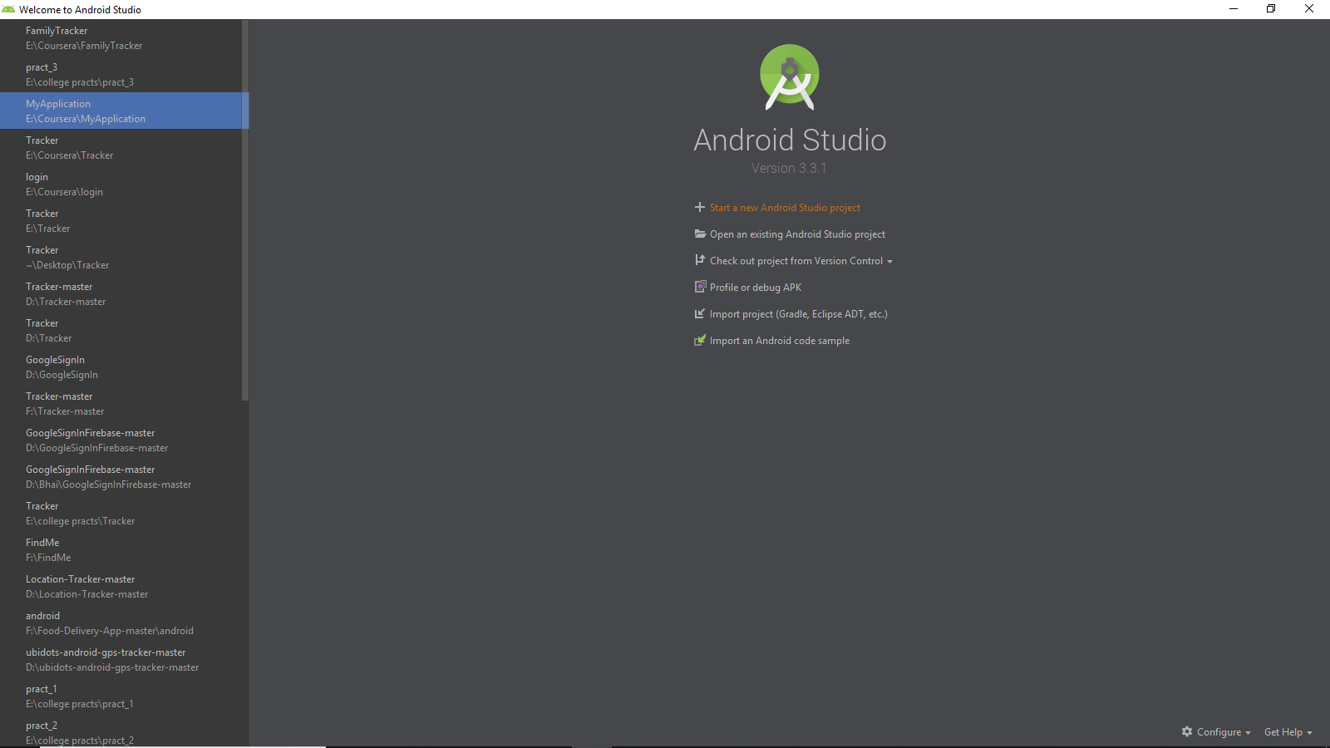

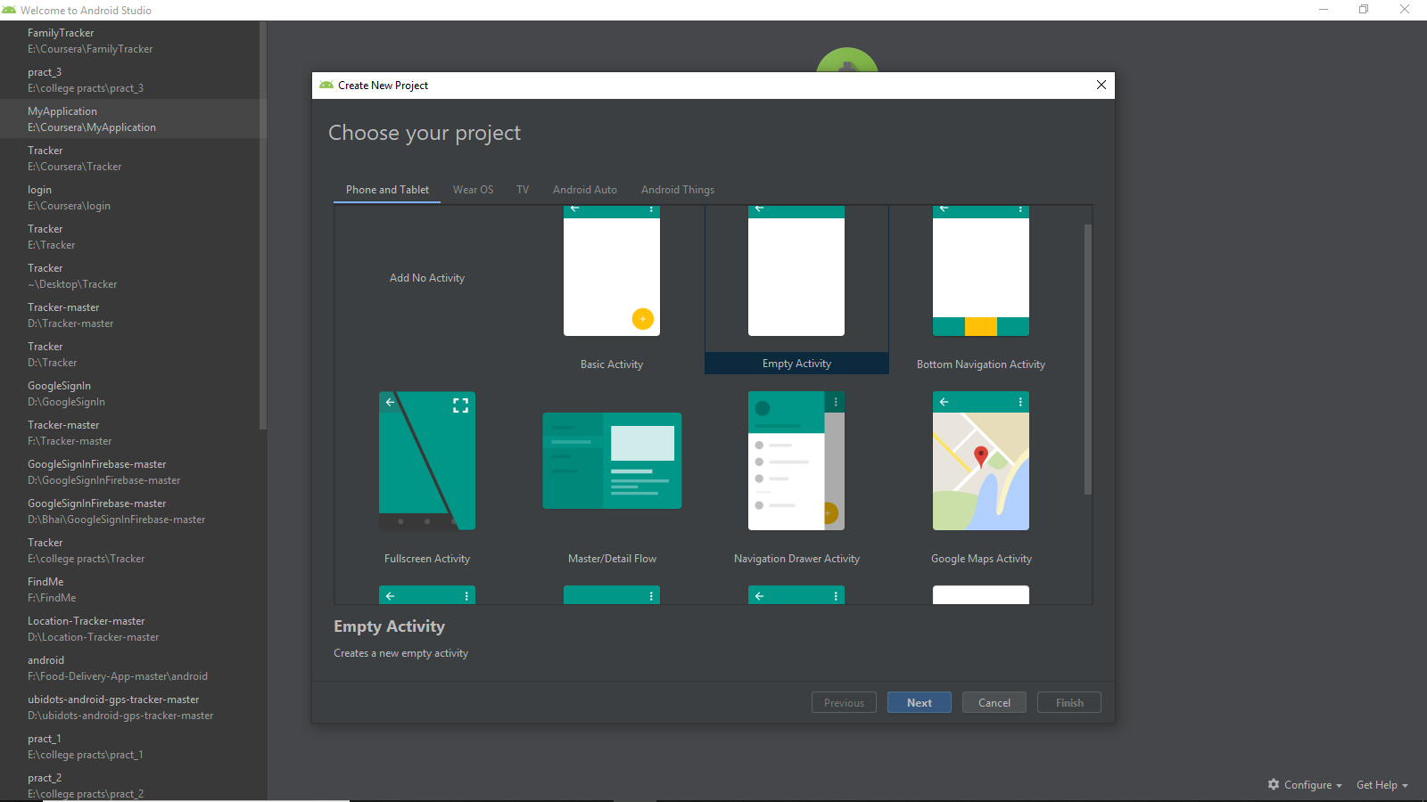

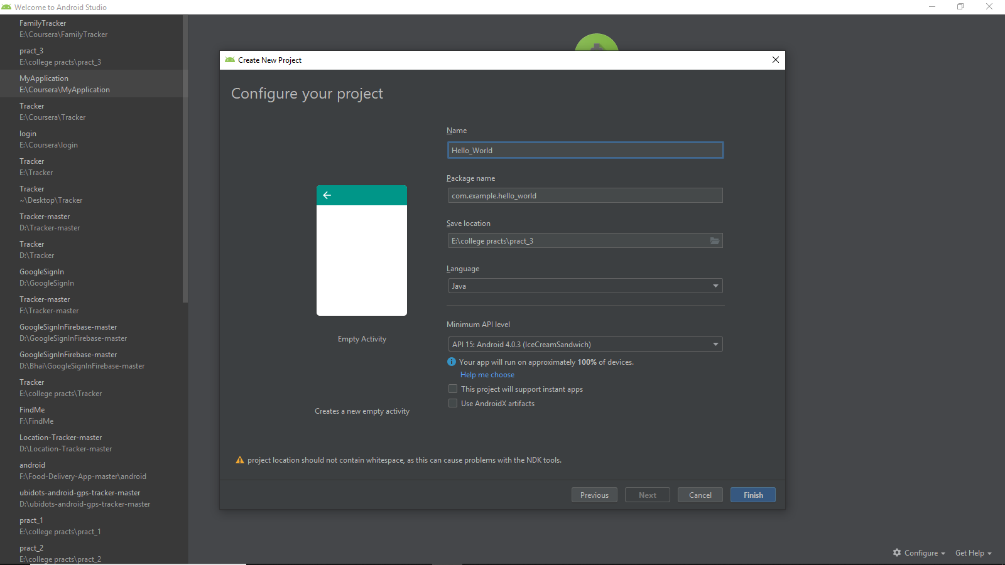

Activity_main.xml:

<?xml version="1.0" encoding="utf-8"?>  
<android.support.constraint.ConstraintLayout  
 xmlns:android="http://schemas.android.com/apk/res/android"  
 xmlns:tools="http://schemas.android.com/tools"  
 xmlns:app="http://schemas.android.com/apk/res-auto"  
 android:layout_width="match_parent"  
 android:layout_height="match_parent"  
 tools:context=".MainActivity">  
  
 <TextView  
 android:layout_width="wrap_content"  
 android:layout_height="wrap_content"  
 android:text="Hello World!"  
 app:layout_constraintBottom_toBottomOf="parent"  
 app:layout_constraintLeft_toLeftOf="parent"  
 app:layout_constraintRight_toRightOf="parent"  
 app:layout_constraintTop_toTopOf="parent" />  
  
</android.support.constraint.ConstraintLayout>

MainActivity.kt

package com.example.myapplication;  
  
import android.support.v7.app.AppCompatActivity;  
import android.os.Bundle;  
  
public class MainActivity extends AppCompatActivity {  
  
 @Override  
 protected void onCreate(Bundle savedInstanceState) {  
 super.onCreate(savedInstanceState);  
 setContentView(R.layout.*activity_main*);  
 }  
}

**Broadcast Activity:**

**Activity_main.xml:**

<?xml version="1.0" encoding="utf-8"?>  
<android.support.constraint.ConstraintLayout  
 xmlns:android="http://schemas.android.com/apk/res/android"  
 xmlns:tools="http://schemas.android.com/tools"  
 xmlns:app="http://schemas.android.com/apk/res-auto"  
 android:layout_width="match_parent"  
 android:layout_height="match_parent"  
 tools:context=".MainActivity">  
 <ImageView  
 android:id="@+id/imageView"  
 android:layout_width="40dp"  
 android:layout_height="40dp"  
 android:layout_margin="8dp"  
 android:layout_marginTop="16dp"  
 app:layout_constraintStart_toStartOf="parent"  
 app:layout_constraintTop_toTopOf="parent"  
 android:src="@drawable/ic_airplanemode_active_black_24dp"  
 app:layout_constraintEnd_toStartOf="@+id/textView"  
 android:layout_marginEnd="32dp"  
 android:layout_marginRight="32dp"  
 />  
 <TextView  
 android:id="@+id/textView"  
 android:layout_width="300dp"  
 android:layout_height="36dp"  
 android:layout_marginEnd="8dp"  
 android:layout_marginStart="8dp"  
 android:gravity="center_vertical"  
 android:text="Flight Mode"  
 android:textColor="@android:color/black"  
 android:textSize="24dp"  
 app:layout_constraintEnd_toEndOf="parent"  
 app:layout_constraintStart_toEndOf="@+id/imageView"  
 app:layout_constraintTop_toTopOf="@+id/imageView" />  
  
</android.support.constraint.ConstraintLayout>

**MainActivity:**

package com.example.clgprac1  
  
  
import android.support.v7.app.AppCompatActivity  
import android.os.Bundle  
  
class MainActivity : AppCompatActivity() {  
  
 override fun onCreate(savedInstanceState: Bundle?) {  
 super.onCreate(savedInstanceState)  
 setContentView(R.layout.*activity_main*)  
  
 }  
}

**MyReciver.kt:**

package com.example.clgprac1  
  
  
import android.content.BroadcastReceiver  
import android.content.Context  
import android.content.Intent  
import android.widget.Toast  
class MyReceiver : BroadcastReceiver()  
{  
 override fun onReceive(context: Context, intent: Intent)  
 {  
 // *TODO: This method is called when the BroadcastReceiver is receiving an Intent broadcast.* Toast.makeText(context, "Broadcast : Flight mode changed.",  
 Toast.*LENGTH_LONG*).show()  
 }  
  
}

**AndroidMainfest.xml**

<?xml version="1.0" encoding="utf-8"?>  
<manifest xmlns:android="http://schemas.android.com/apk/res/android"  
 package="com.example.clgprac1">  
  
 <application  
 android:allowBackup="true"  
 android:icon="@mipmap/ic_launcher"  
 android:label="@string/app_name"  
 android:roundIcon="@mipmap/ic_launcher_round"  
 android:supportsRtl="true"  
 android:theme="@style/AppTheme">  
 <activity android:name=".MainActivity">  
  
 <intent-filter>  
 <action android:name="android.intent.action.MAIN"/>  
  
 <category android:name="android.intent.category.LAUNCHER"/>  
 </intent-filter>  
 </activity>  
 <activity android:name=".SecondActivity"/>  
 <receiver  
 android:name=".MyReceiver"  
 android:enabled="true"  
 android:exported="true">  
 <intent-filter>  
 <action android:name="android.intent.action.AIRPLANE_MODE"/>  
 </intent-filter>  
 </receiver>  
 </application>  
  
</manifest>

Create and manage virtual devices:

To open the AVD Manager, do one of the following:

• Select Tools > AVD Manager.

• Click AVD Manager AVD Manager icon the toolbar.

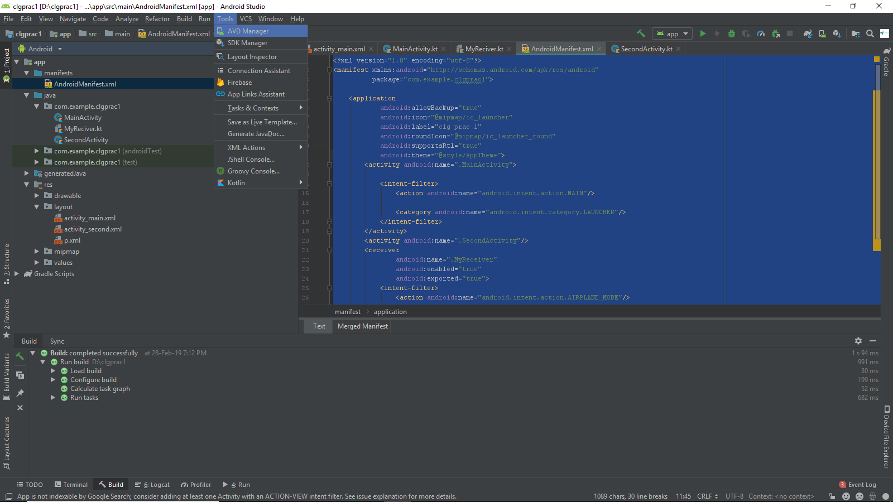

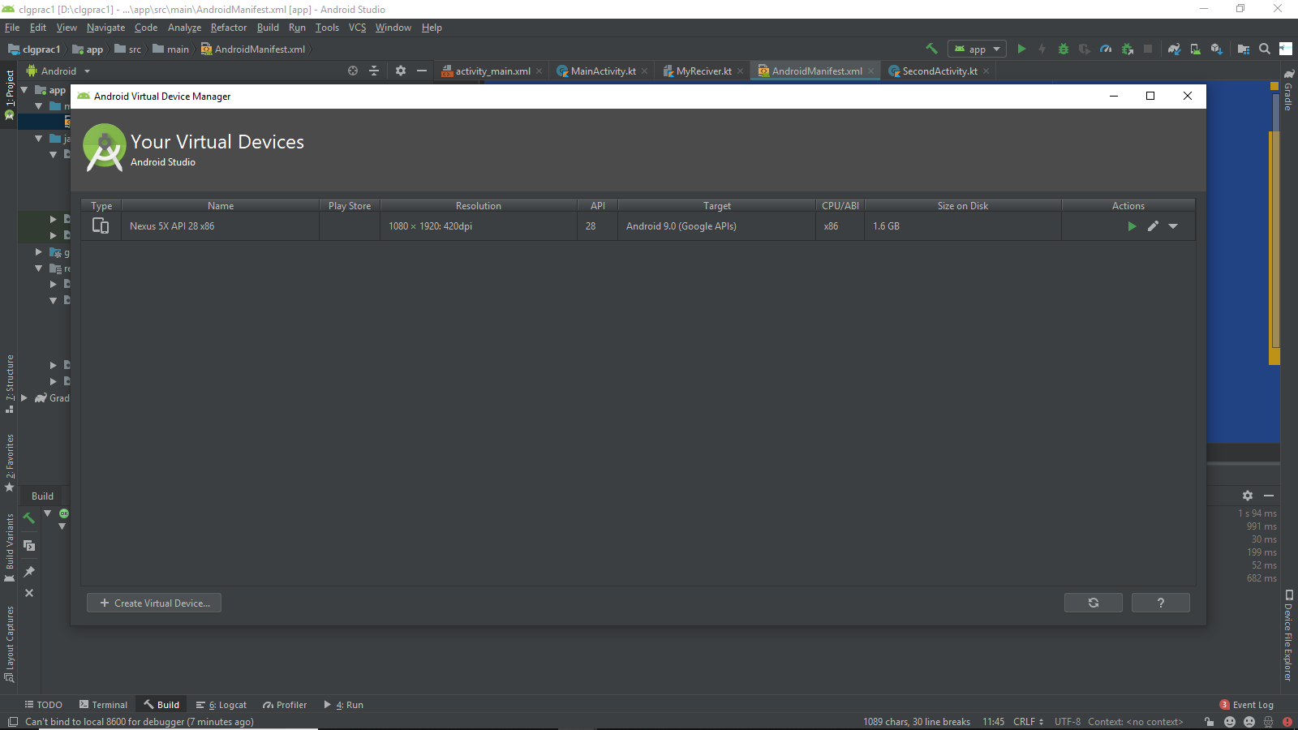

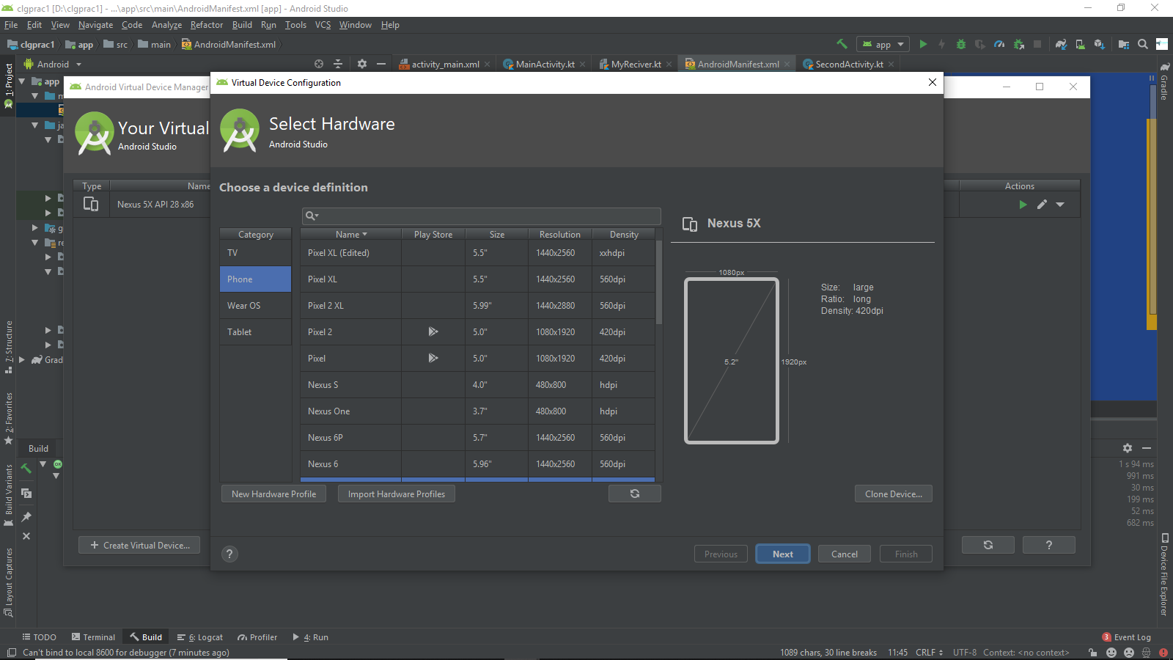

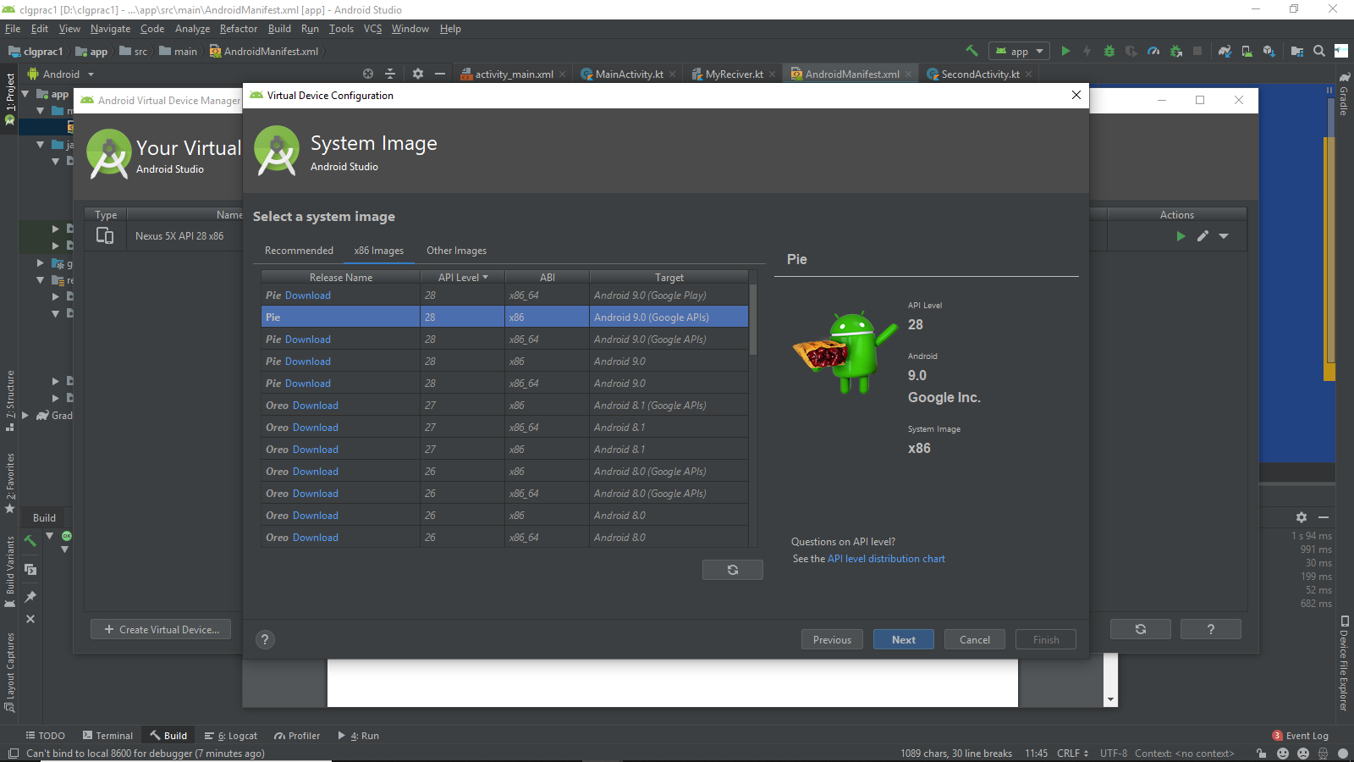

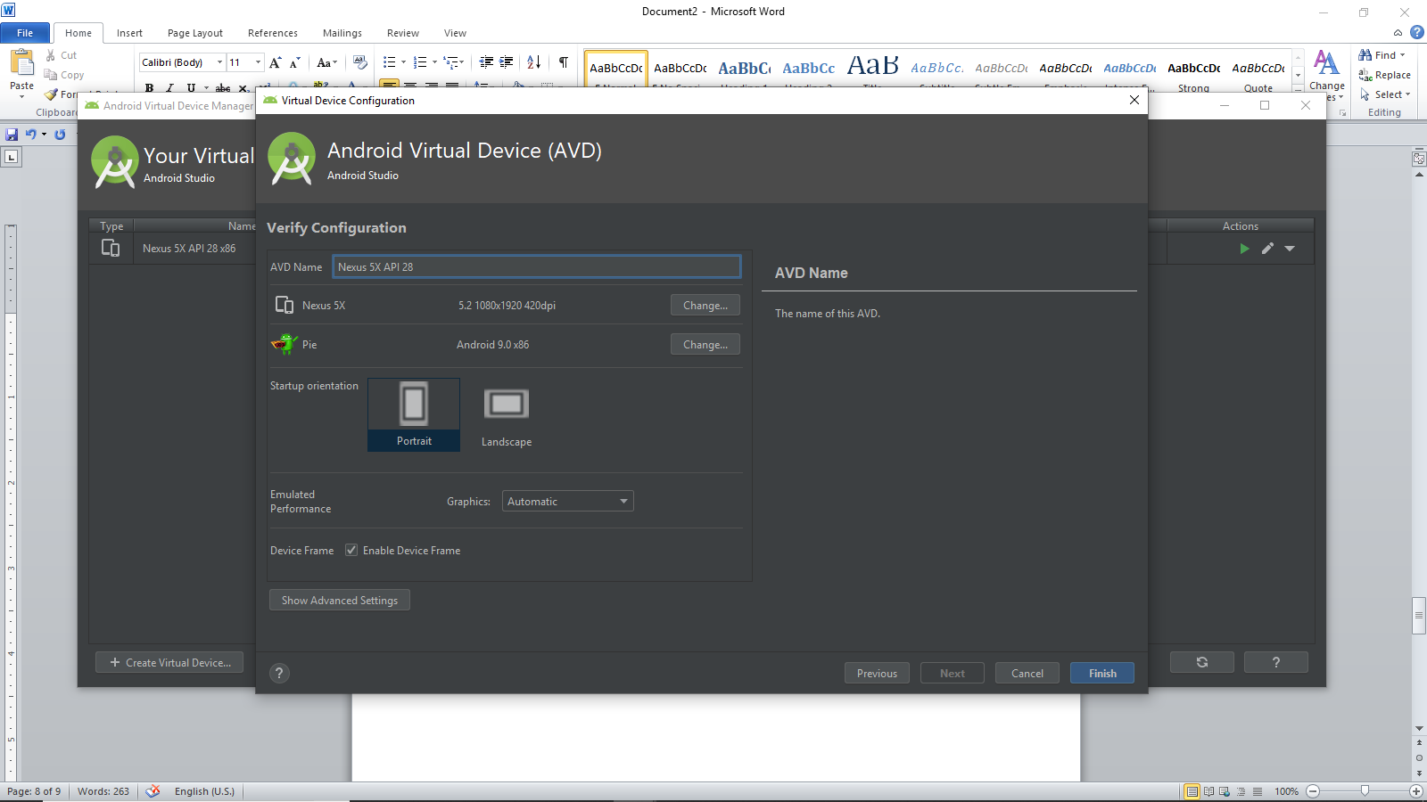

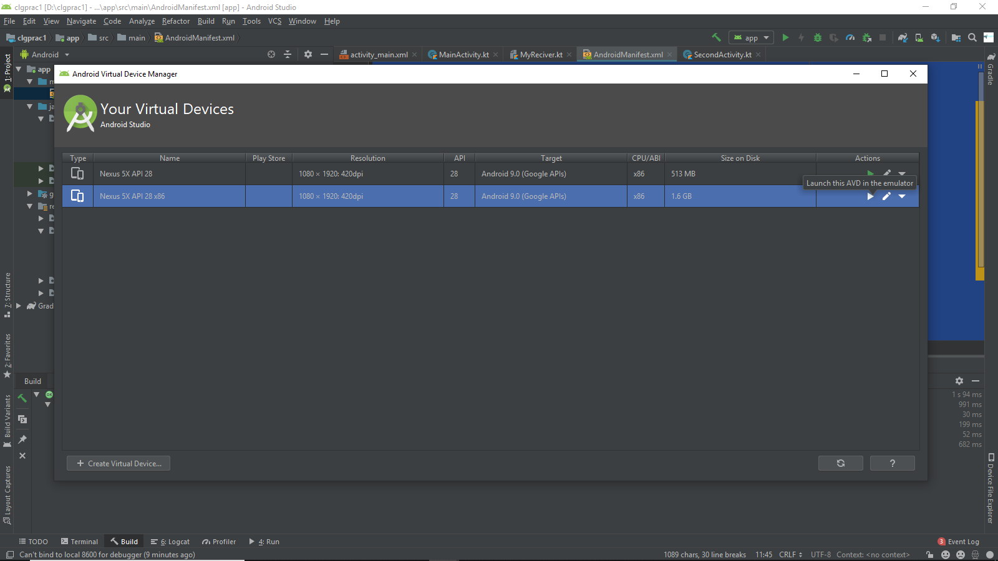

**Output:**

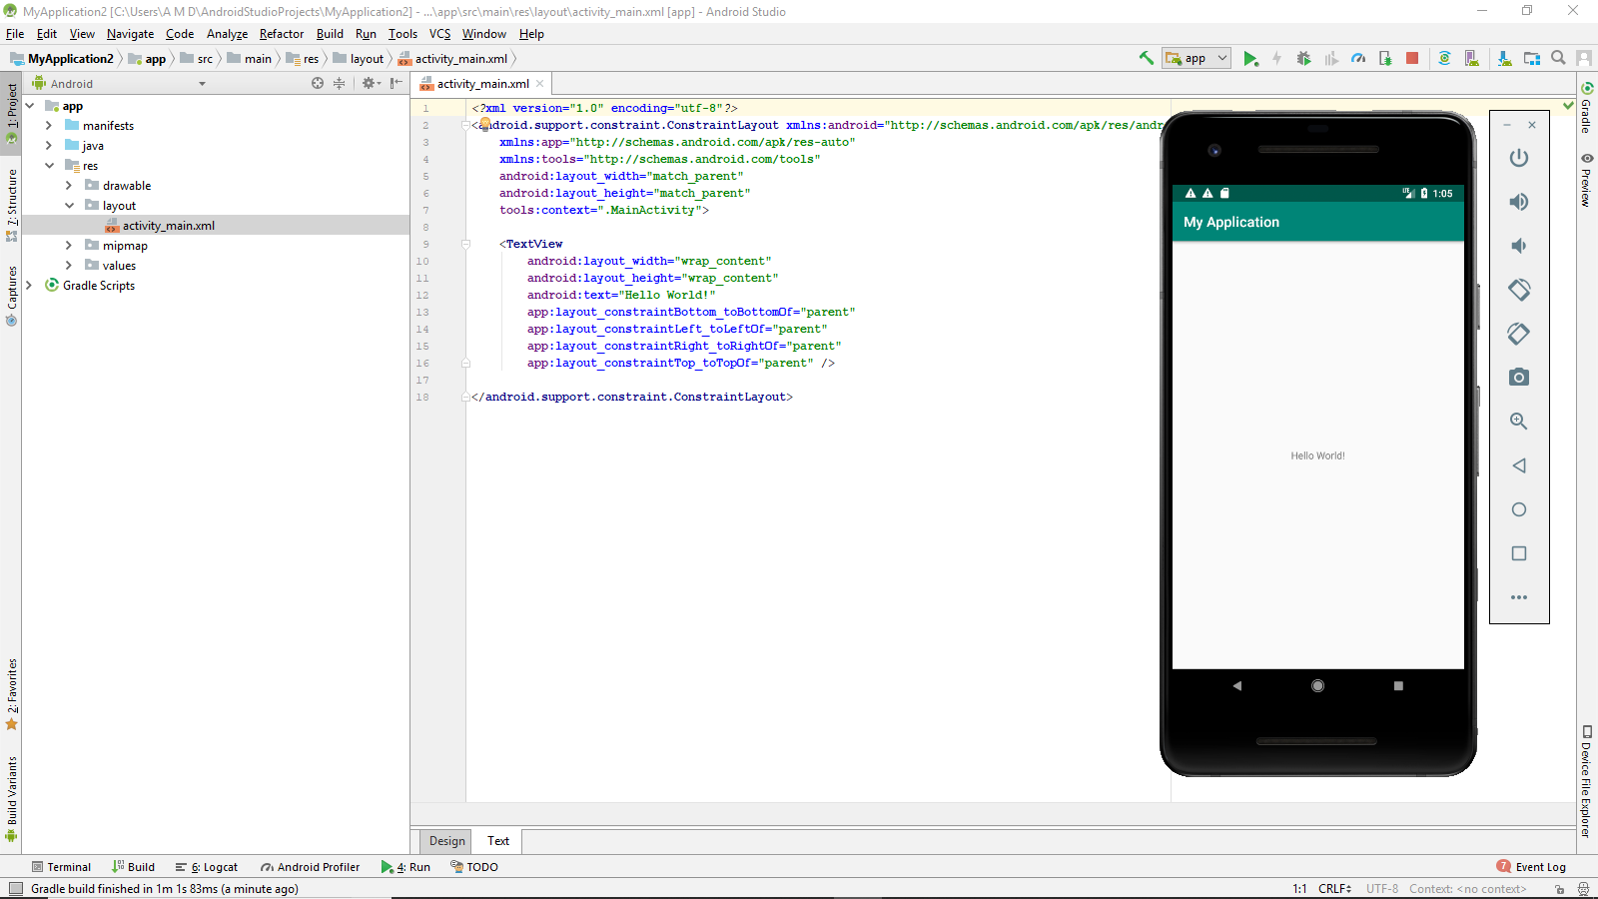

**PRACTICAL 2**

Android Resources: (Color, Theme, String, Drawable, Dimension, Image)

Colors:

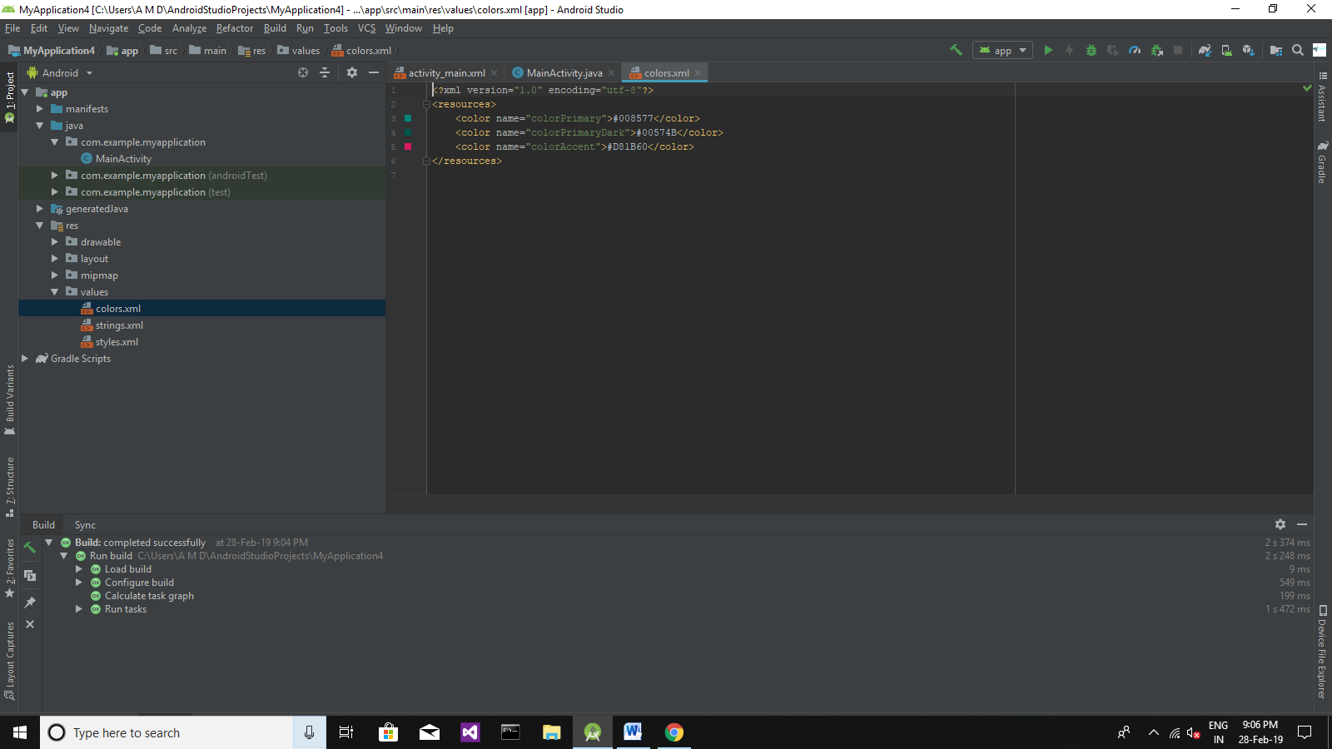

Colors.xml

<?xml version="1.0" encoding="utf-8"?>  
<resources>  
 <color name="colorPrimary">#008577</color>  
 <color name="colorPrimaryDark">#00574B</color>  
 <color name="colorAccent">#D81B60</color>  
</resources>

Style.xml

<resources>  
  
 <!-- Base application theme. -->  
 <style name="AppTheme" parent="Theme.AppCompat.Light.DarkActionBar">  
 <!-- Customize your theme here. -->  
 <item name="colorPrimary">@color/colorPrimary</item>  
 <item name="colorPrimaryDark">@color/colorPrimaryDark</item>  
 <item name="colorAccent">@color/colorAccent</item>  
 </style>  
  
</resources>

Strings.xml

<resources>  
 <string name="app_name">MyApplication</string>  
</resources>

Drawable:

1. Right click on Drawable folder.
2. Copy the image if you want to create image Drawable.
3. Paste that image file inside the Drawable folder.

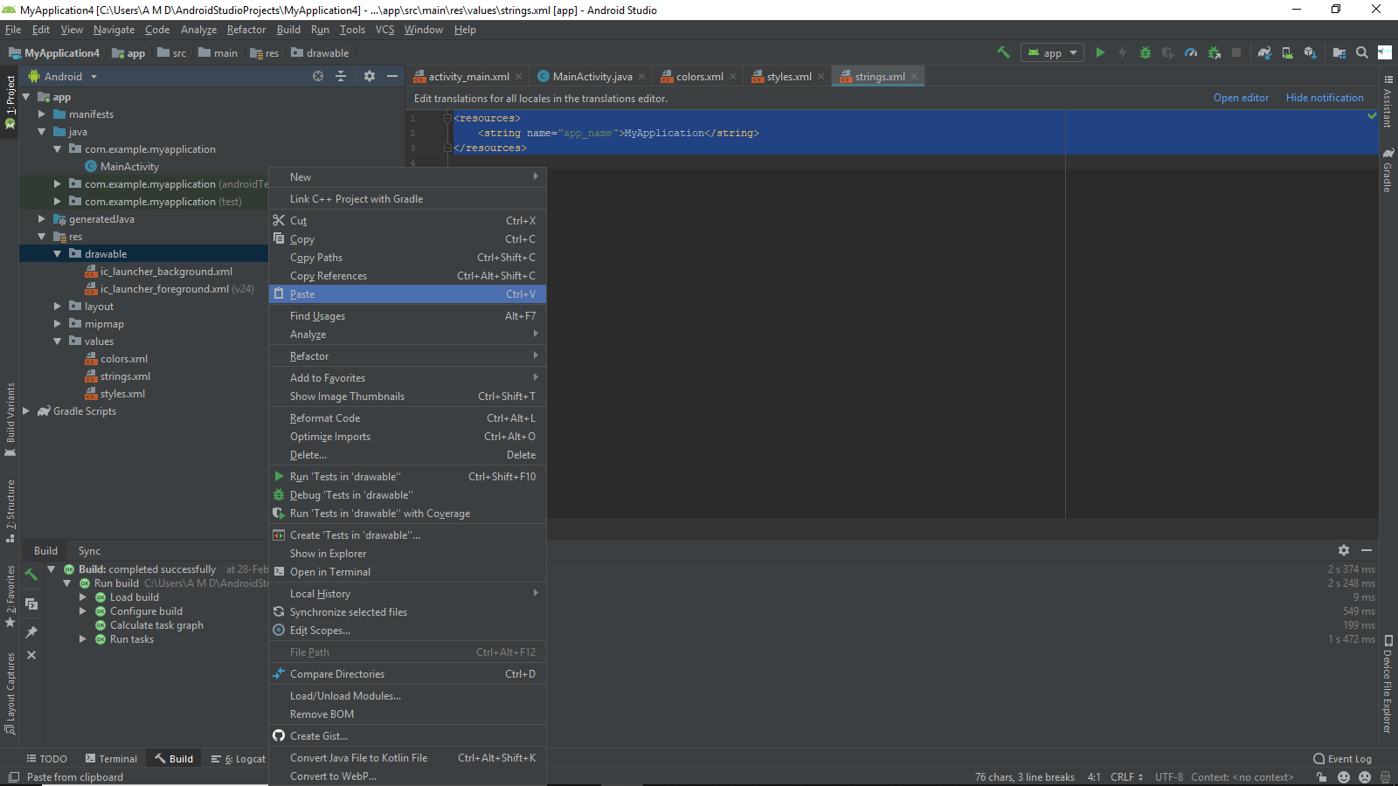

**Activity_main.xml**

<?xml version="1.0" encoding="utf-8"?>  
<androidx.constraintlayout.widget.ConstraintLayout xmlns:android="http://schemas.android.com/apk/res/android"  
 xmlns:app="http://schemas.android.com/apk/res-auto"  
 xmlns:tools="http://schemas.android.com/tools"  
 android:layout_width="match_parent"  
 android:layout_height="match_parent"  
 android:background="@drawable/wallmax"  
 tools:context=".MainActivity">  
  
 <TextView  
 android:layout_width="wrap_content"  
 android:layout_height="wrap_content"  
 android:text="Hello World!"  
 app:layout_constraintBottom_toBottomOf="parent"  
 app:layout_constraintLeft_toLeftOf="parent"  
 app:layout_constraintRight_toRightOf="parent"  
 app:layout_constraintTop_toTopOf="parent" />  
  
</androidx.constraintlayout.widget.ConstraintLayout>

**Image background output:**

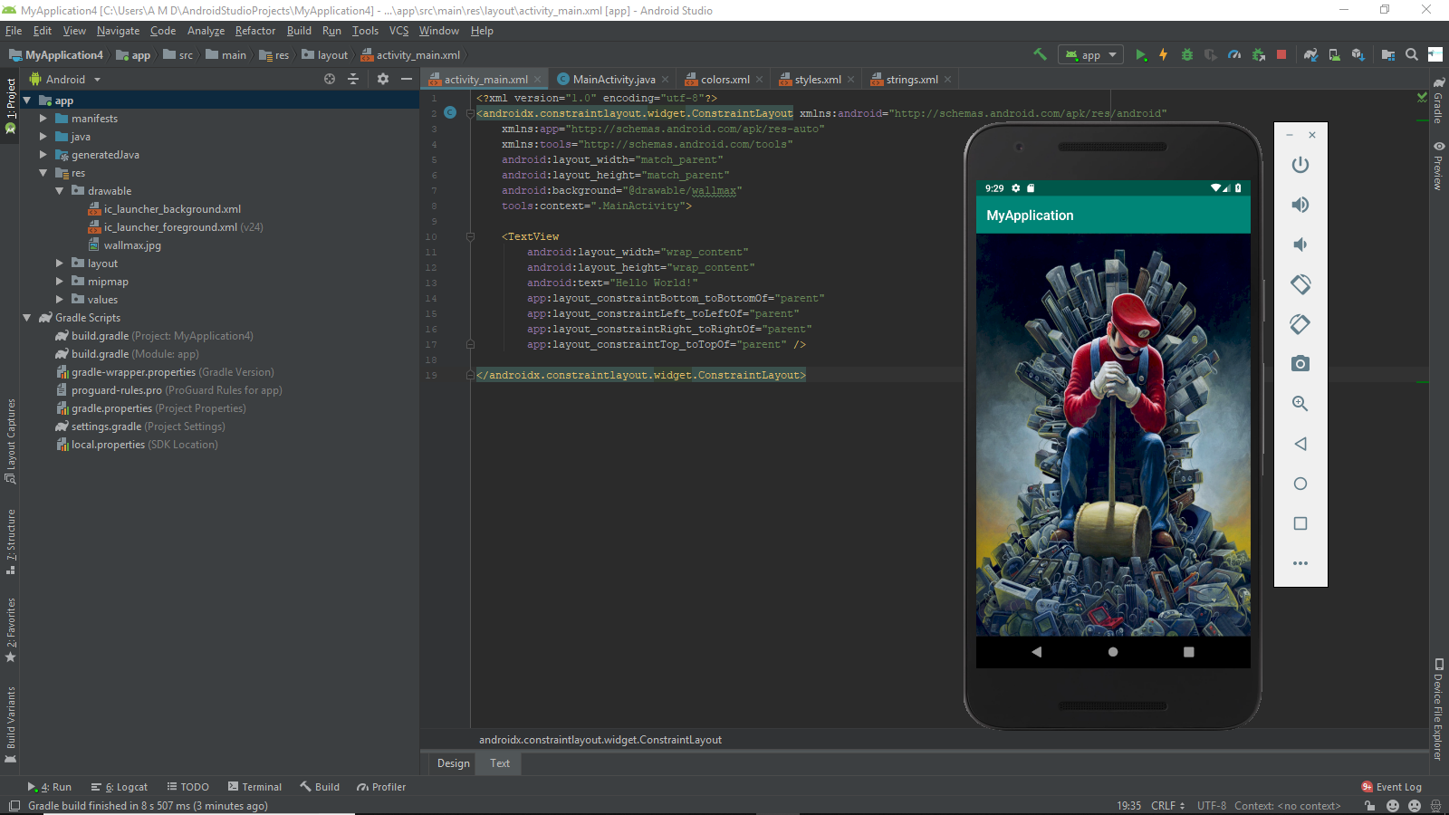

PRACTICAL 3

Programming Activities and fragments

Activity Life Cycle, Activity methods, Multiple Activities, Life Cycle of fragments and multiple fragments.

Activity Lifecycle:

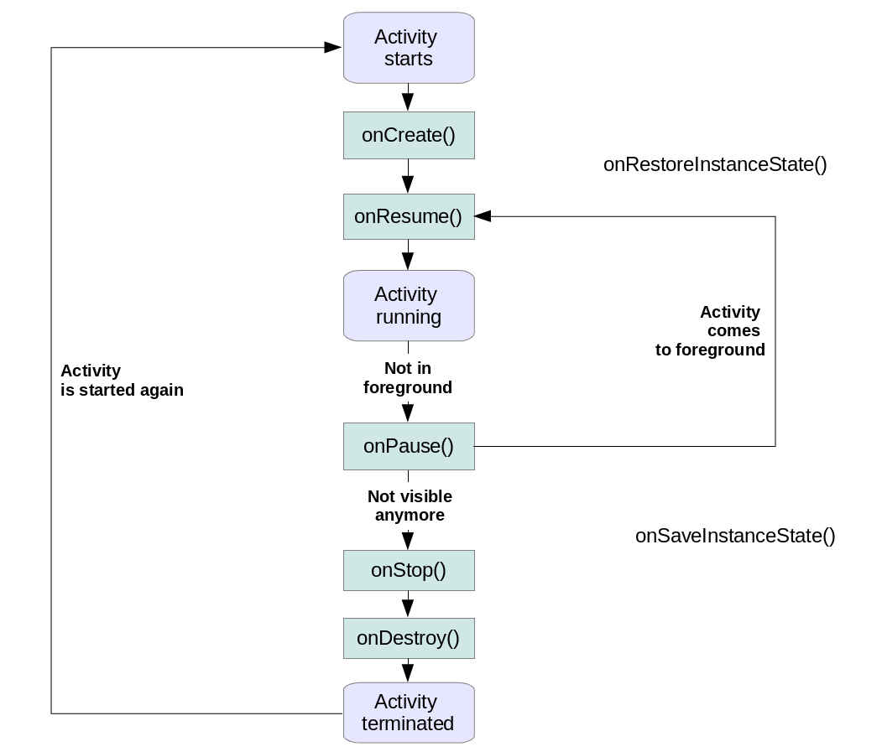

To create a fragment, you must create a subclass of Fragment (or an existing subclass of it). The Fragment class has code that looks a lot like an Activity. It contains callback methods similar to an activity, such as **onCreate(), onStart(), onPause(), and onStop().** In fact, if you're converting an existing Android application to use fragments, you might simply move code from your activity's callback methods into the respective callback methods of your fragment.

* onCreate(): Called by the OS when the activity is first created. This is where you initialize any UI elements or data objects. You also have the savedInstanceState of the activity that contains its previously saved state, and you can use it to recreate that state.
* onStart(): Just before presenting the user with an activity, this method is called. It’s always followed by onResume(). In here, you generally should start UI animations, audio based content or anything else that requires the activity’s contents to be on screen.
* onResume(): As an activity enters the foreground, this method is called. Here you have a good place to restart animations, update UI elements, restart camera previews, resume audio/video playback or initialize any components that you release during onPause().
* onPause(): This method is called before sliding into the background. Here you should stop any visuals or audio associated with the activity such as UI animations, music playback or the camera. This method is followed by onResume() if the activity returns to the foreground or by onStop() if it becomes hidden.
* onStop(): This method is called right after onPause(), when the activity is no longer visible to the user, and it’s a good place to save data that you want to commit to the disk. It’s followed by either onRestart(), if this activity is coming back to the foreground, or onDestroy() if it’s being released from memory.
* •onRestart(): Called after stopping an activity, but just before starting it again. It’s always followed by onStart().
* onDestroy(): This is the final callback you’ll receive from the OS before the activity is destroyed. You can trigger an activity’s desctruction by calling finish(), or it can be triggered by the system when the system needs to recoup memory. If your activity includes any background threads or other long-running resources, destruction could lead to a memory leak if they’re not released, so you need to remember to stop these processes here as well.

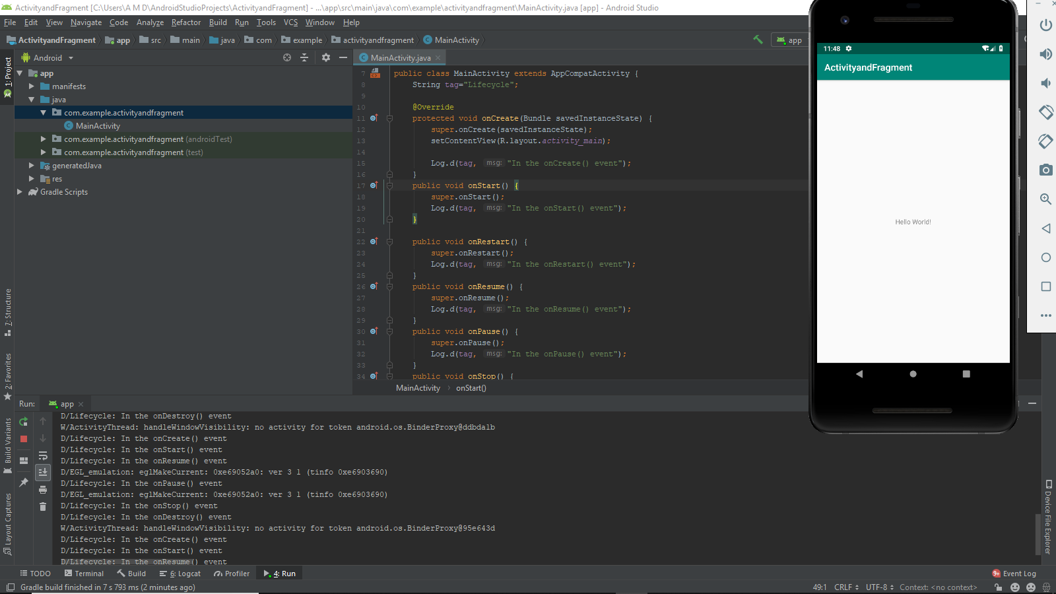

MainActivity.kt

package com.example.activityandfragment;  
  
import android.support.v7.app.AppCompatActivity;  
import android.os.Bundle;  
import android.util.Log;  
  
public class MainActivity extends AppCompatActivity {  
 String tag="Lifecycle";  
  
 @Override  
 protected void onCreate(Bundle savedInstanceState) {  
 super.onCreate(savedInstanceState);  
 setContentView(R.layout.*activity_main*);  
  
 Log.*d*(tag, "In the onCreate() event");  
 }  
 public void onStart() {  
 super.onStart();  
 Log.*d*(tag, "In the onStart() event");  
 }  
  
 public void onRestart() {  
 super.onRestart();  
 Log.*d*(tag, "In the onRestart() event");  
 }  
 public void onResume() {  
 super.onResume();  
 Log.*d*(tag, "In the onResume() event");  
 }  
 public void onPause() {  
 super.onPause();  
 Log.*d*(tag, "In the onPause() event");  
 }  
 public void onStop() {  
 super.onStop();  
 Log.*d*(tag, "In the onStop() event");  
 }  
 public void onDestroy() {  
 super.onDestroy();  
 Log.*d*(tag, "In the onDestroy() event");  
 }  
}

**Creating a Fragment:**

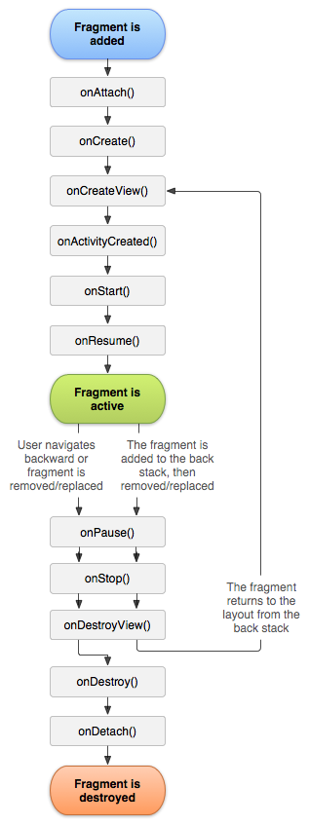

**Add a new Fragment: java ->New->Fragment->Fragment(Blank)**

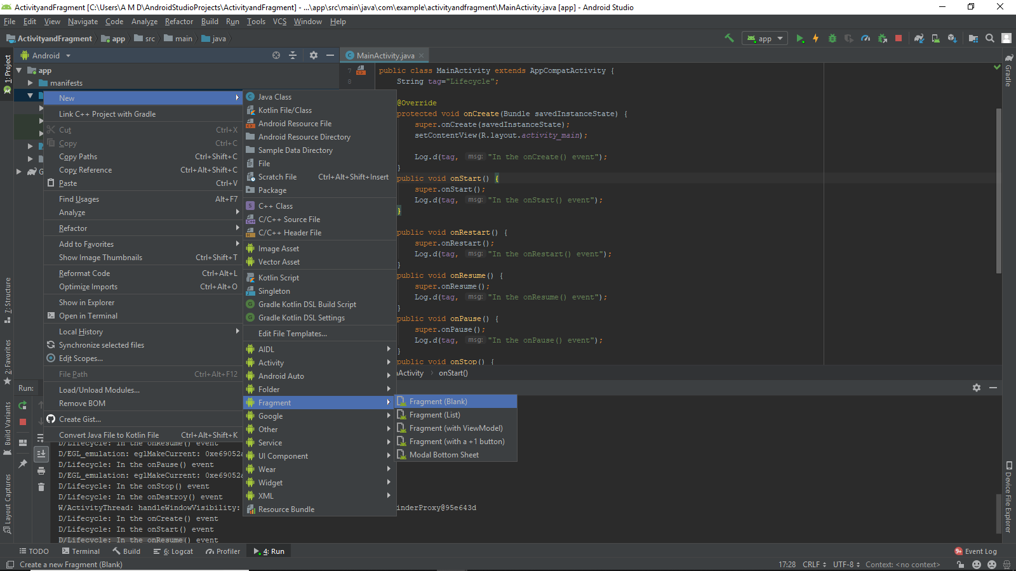

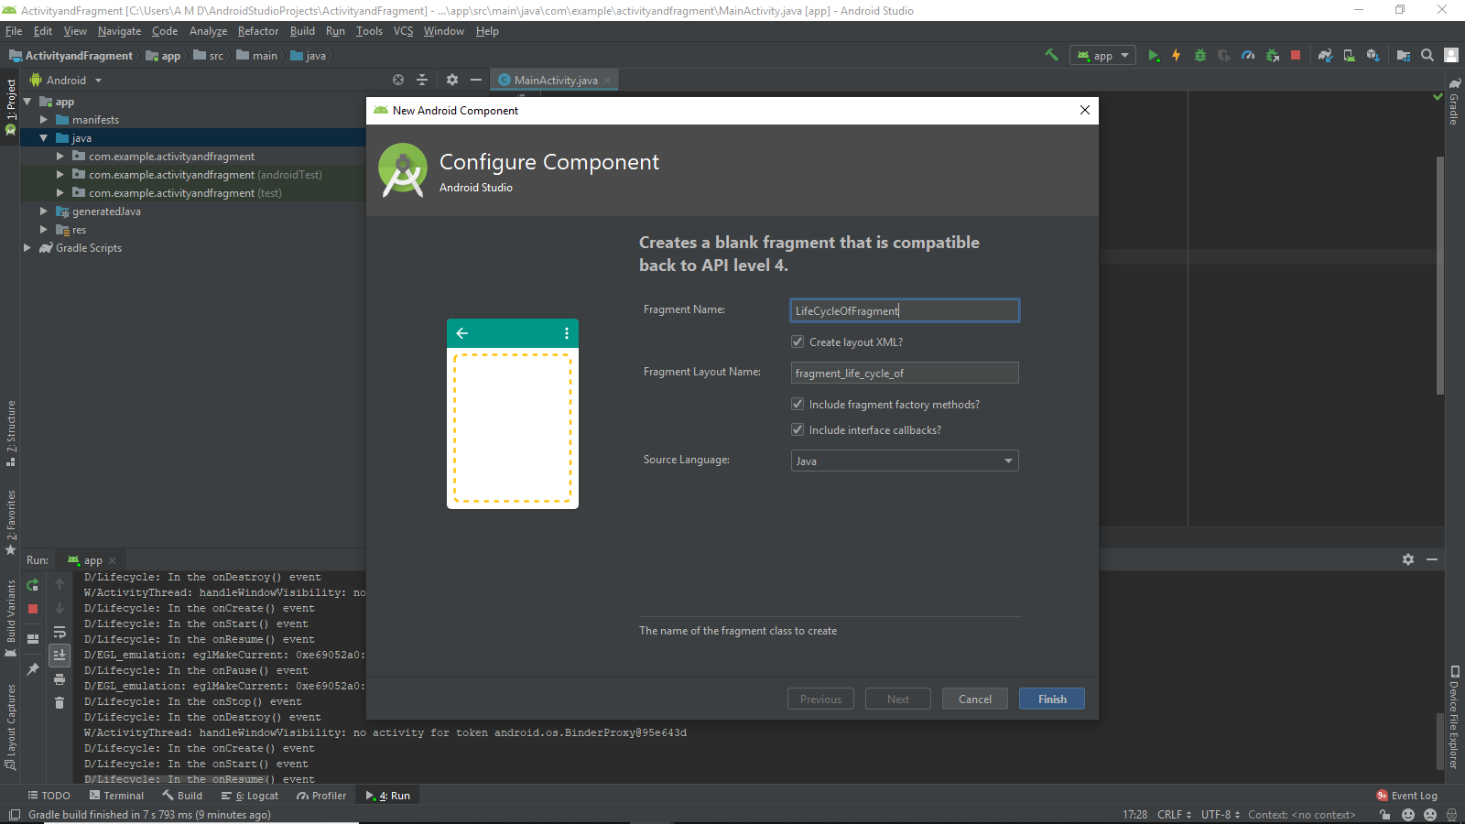

**Press Alt+Ins in the LifeofFragment.java**

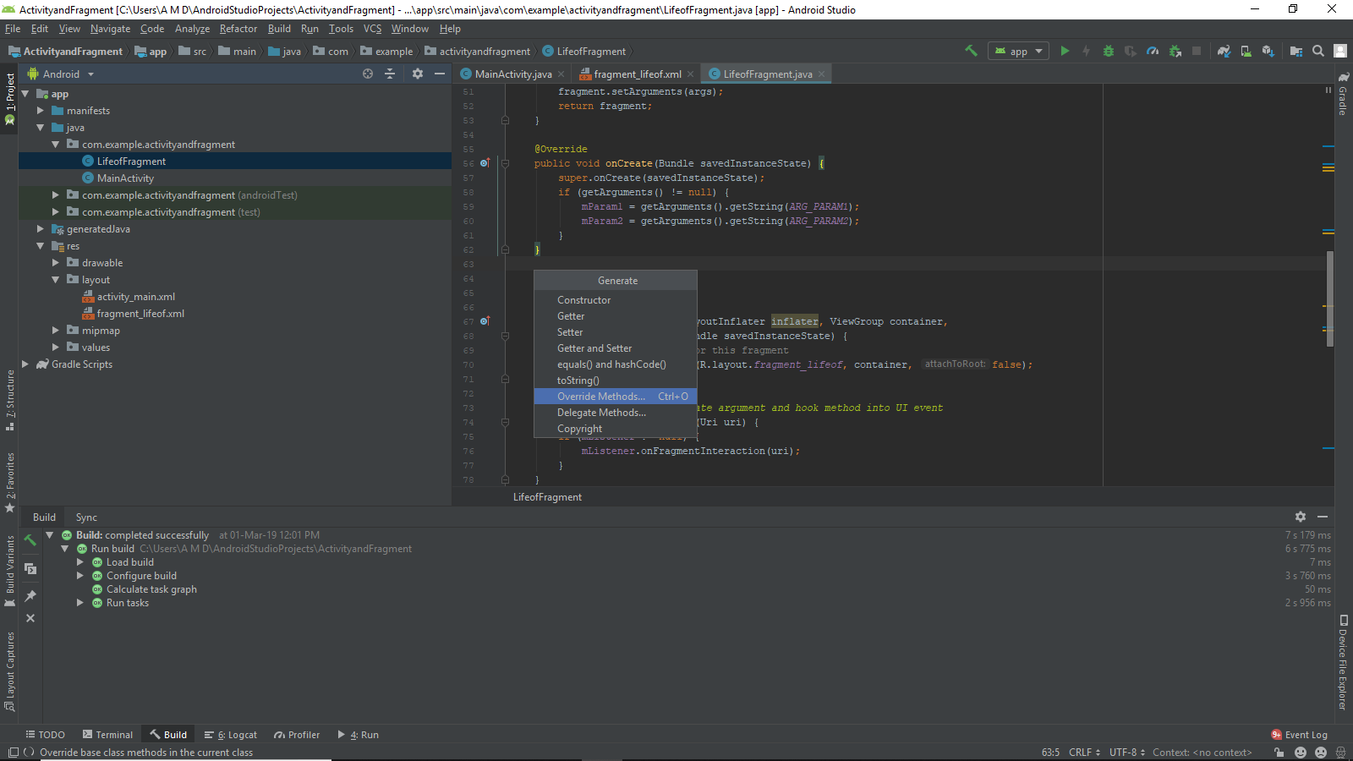

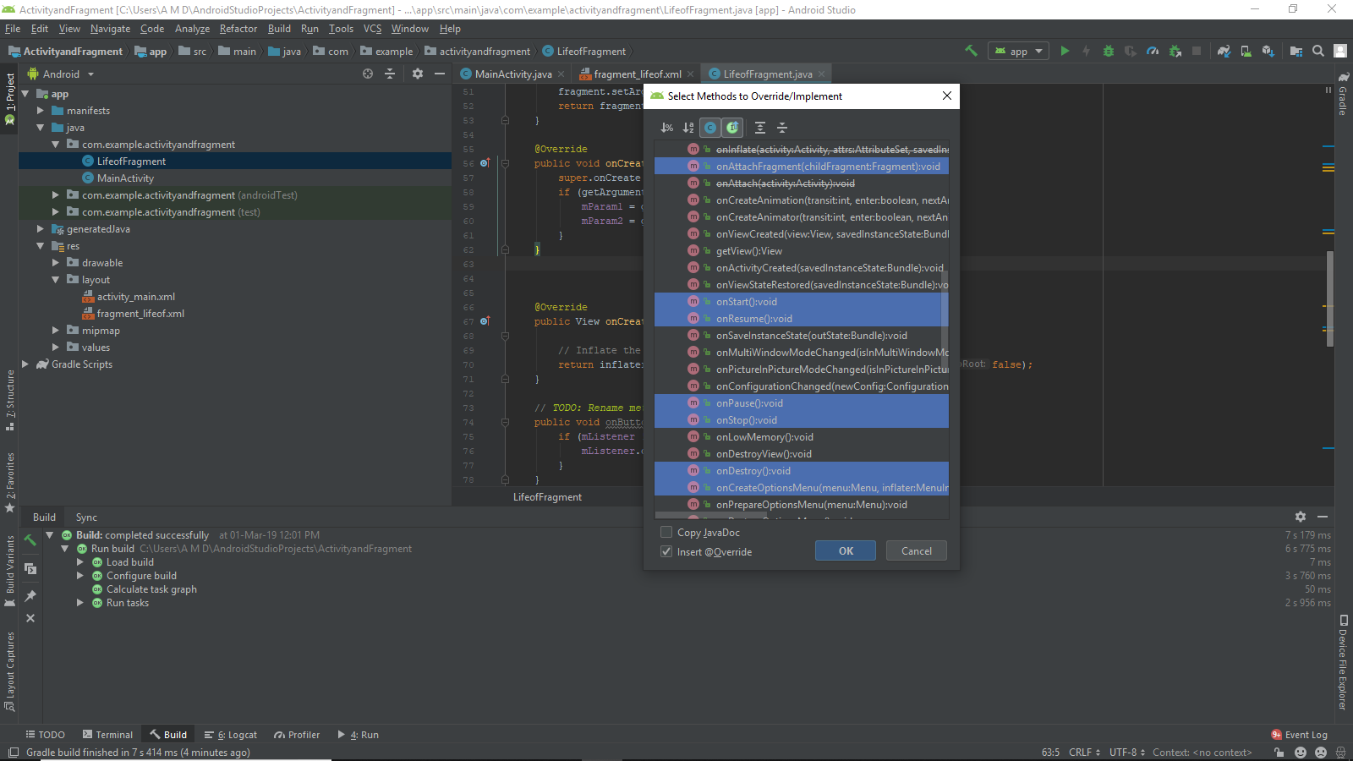

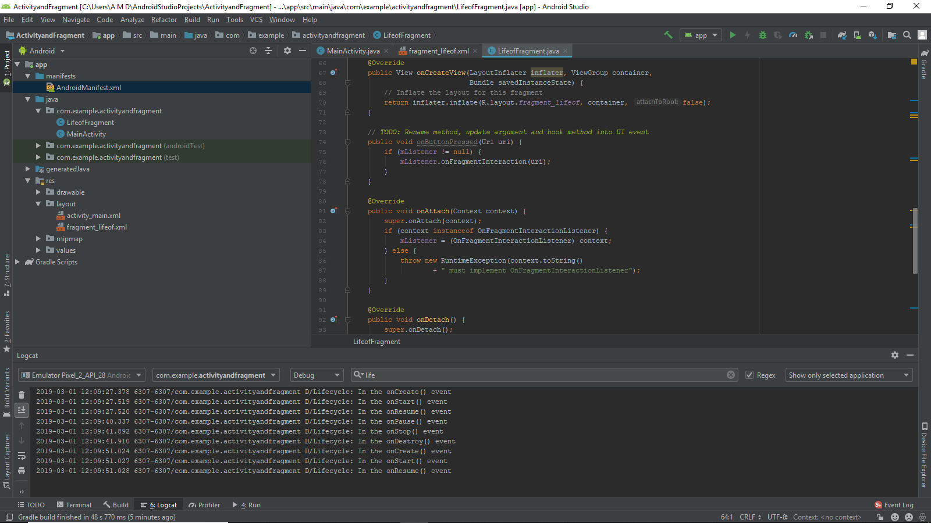

**PRACTICAL 4**

**Aim : Programs related to different Layouts**

Coordinate, Linear, Relative, Table, Absolute, Frame, List View, Grid View.

Right click on app ->New->Activity->Empty Activity

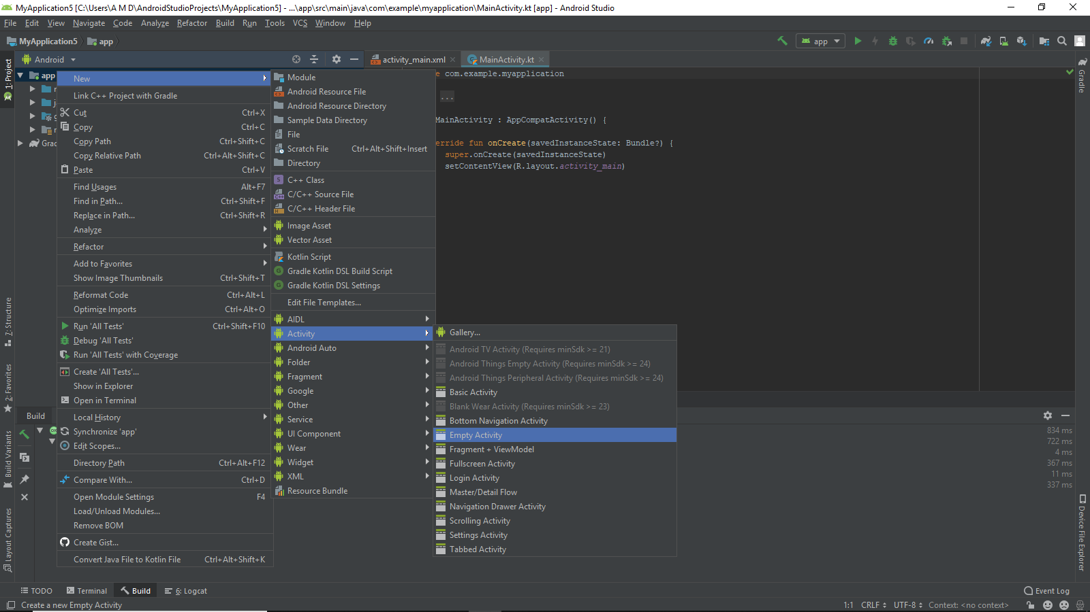

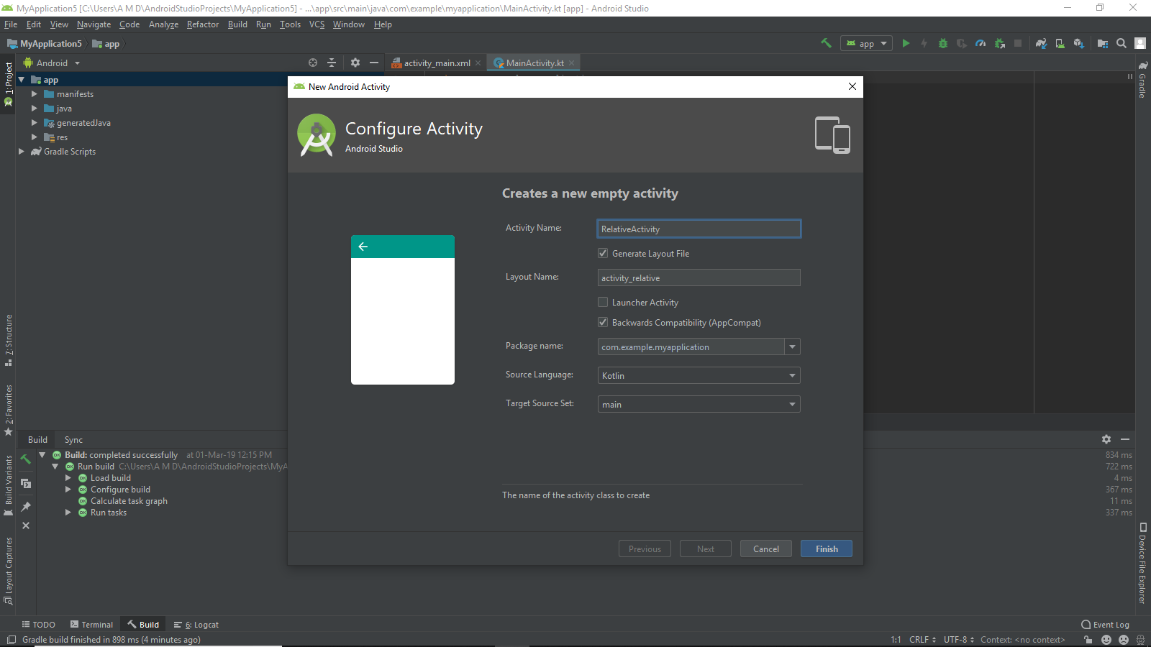

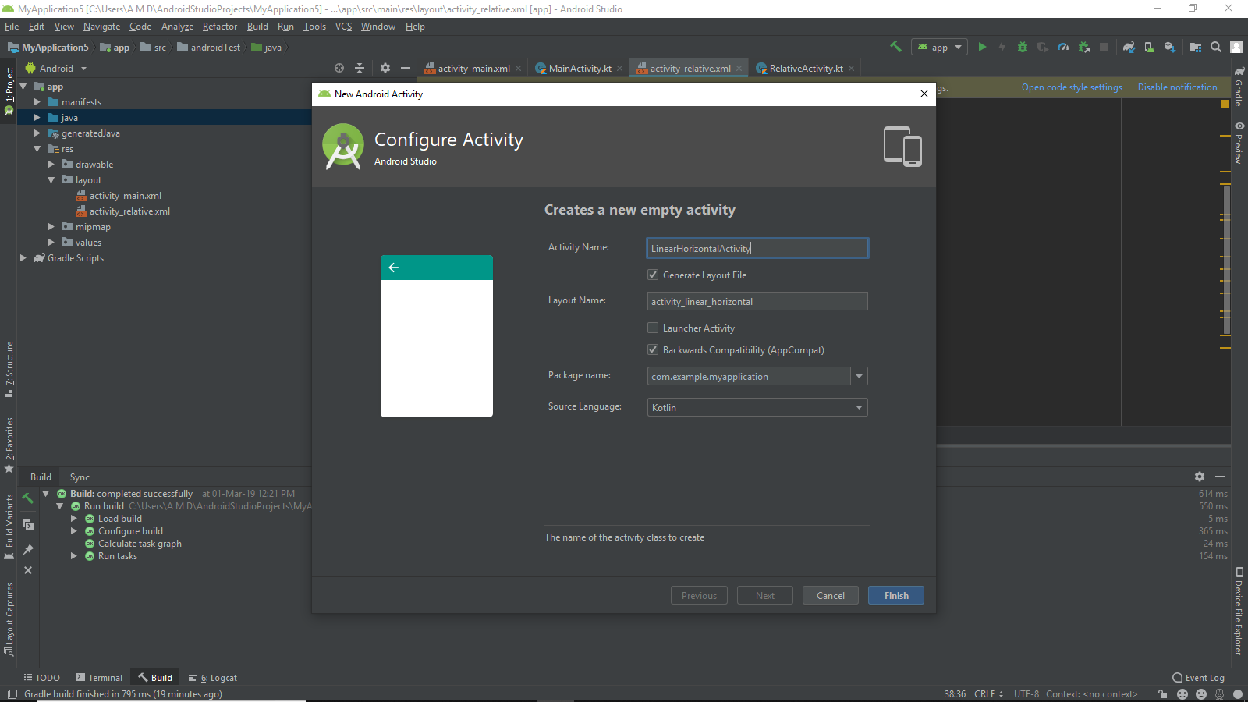

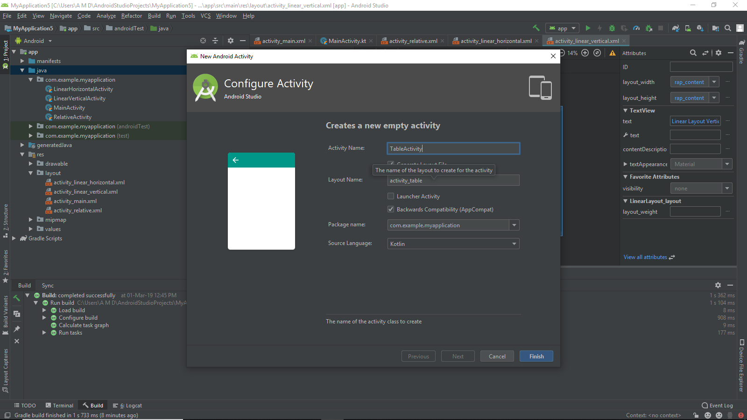

**Similarly create Activities:**

* **Linear Vertical Activity**
* **Scroll Activity**
* **Absolute Activity**
* **List View Activity**
* **Grid View Activity**
* **Frame Activity**

**activity_absolute.xml**

<?xml version="1.0" encoding="utf-8"?>  
<AbsoluteLayout  
 xmlns:android="http://schemas.android.com/apk/res/android"  
 xmlns:tools="http://schemas.android.com/tools"  
 xmlns:app="http://schemas.android.com/apk/res-auto"  
 android:layout_width="match_parent"  
 android:layout_height="match_parent"  
 tools:context=".AbsoluteActivity">  
 <Button android:layout_width="188dp"  
 android:layout_height="wrap_content"  
 android:layout_x="50px"  
 android:layout_y="30px"  
 android:text="Button 1"  
 />  
 <Button android:layout_width="188dp"  
 android:layout_height="wrap_content"  
 android:layout_x="200px"  
 android:layout_y="550px"  
 android:text="Button 2"  
 />  
 <Button android:layout_width="113dp"  
 android:layout_height="wrap_content"  
 android:layout_x="350px"  
 android:layout_y="740px"  
 android:text="Button 1"  
 />  
  
 <TextView android:layout_width="wrap_content" android:layout_height="wrap_content"  
 android:textAlignment="center"  
 android:textSize="100px"  
 android:text="Absolute Layout"  
 android:layout_y="406dp" android:layout_x="60dp"/>  
  
  
</AbsoluteLayout>

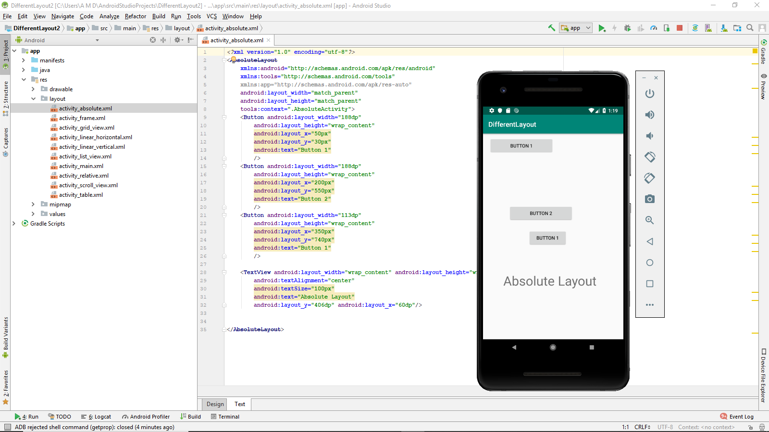

**activity_frame.xml**

<?xml version="1.0" encoding="utf-8"?>  
<RelativeLayout  
 xmlns:android="http://schemas.android.com/apk/res/android"  
 xmlns:tools="http://schemas.android.com/tools"  
 xmlns:app="http://schemas.android.com/apk/res-auto"  
 android:layout_width="match_parent"  
 android:layout_height="match_parent"  
 tools:context=".FrameActivity">  
 <TextView android:layout_width="wrap_content" android:layout_height="wrap_content"  
 android:id="@+id/lblComments"  
 android:text="Hello,Android!!"  
 android:layout_alignParentTop="true"  
 android:layout_alignParentLeft="true"  
 android:textSize="50px"  
 />  
 <FrameLayout android:layout_width="wrap_content" android:layout_height="wrap_content"  
 android:layout_alignLeft="@+id/lblComments"  
 android:layout_below="@+id/lblComments"  
 android:layout_centerHorizontal="true"  
 >  
 <ImageView android:layout_width="wrap_content" android:layout_height="wrap_content"  
 android:src="@mipmap/ic_launcher"  
 />  
 </FrameLayout>  
</RelativeLayout>

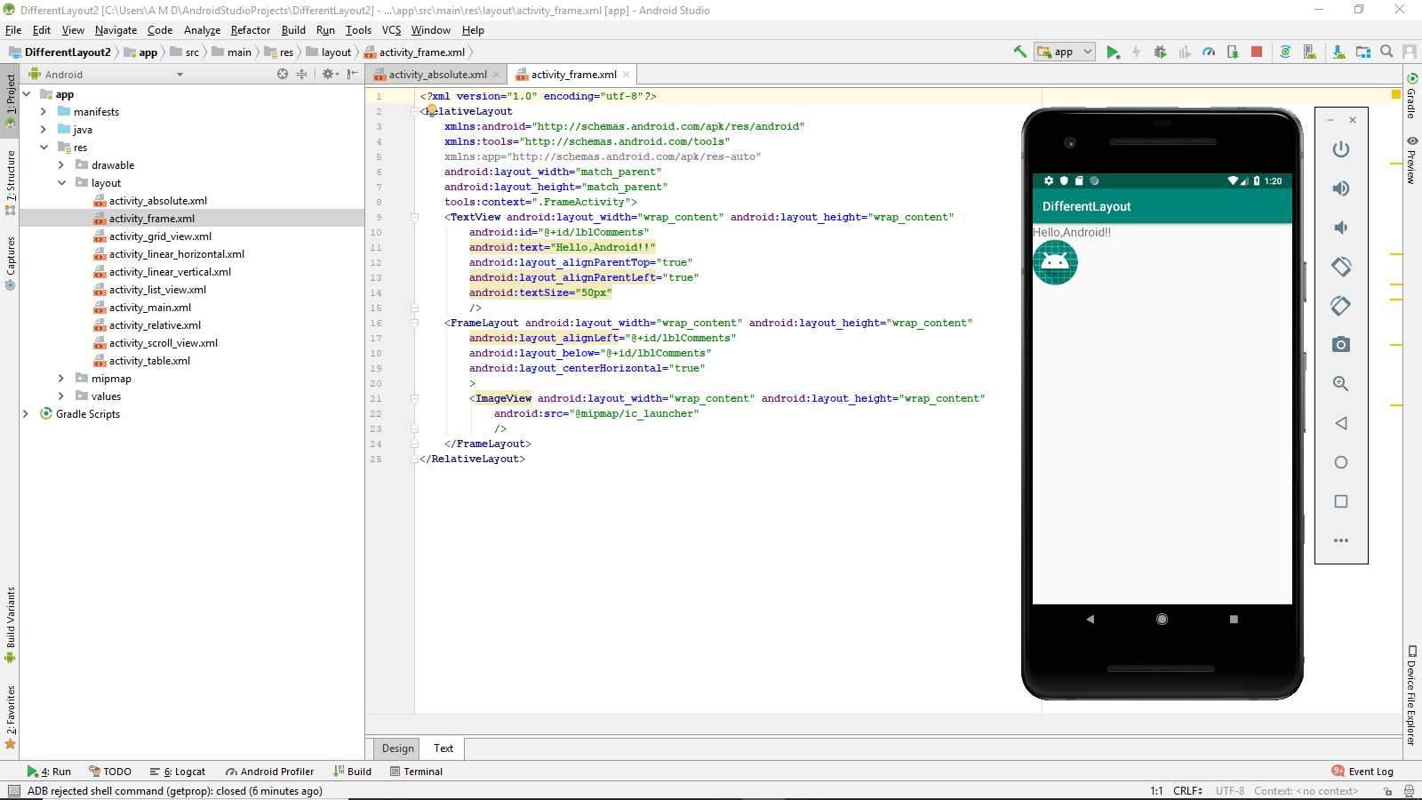

**activity_grid_view.xml**

<?xml version="1.0" encoding="utf-8"?>  
<LinearLayout  
 xmlns:android="http://schemas.android.com/apk/res/android"  
 xmlns:tools="http://schemas.android.com/tools"  
 xmlns:app="http://schemas.android.com/apk/res-auto"  
 android:layout_width="match_parent"  
 android:layout_height="match_parent"  
 android:orientation="vertical"  
 tools:context=".GridViewActivity">  
 <TextView android:layout_width="match_parent" android:layout_height="wrap_content"  
 android:text="Grid View"  
 android:textSize="100px"  
 android:textAlignment="center"  
 android:gravity="center"  
 />  
 <GridView android:layout_width="fill_parent"  
 android:layout_height="fill_parent"  
 android:numColumns="auto_fit"  
 android:verticalSpacing="10dp"  
 android:horizontalSpacing="10dp"  
 android:columnWidth="90dp"  
 android:stretchMode="columnWidth"  
 android:gravity="center"  
 android:id="@+id/gridview"/>  
</LinearLayout>

**activity_linear_Horizontal.xml**

<?xml version="1.0" encoding="utf-8"?>  
<LinearLayout  
 xmlns:android="http://schemas.android.com/apk/res/android"  
 xmlns:tools="http://schemas.android.com/tools"  
 xmlns:app="http://schemas.android.com/apk/res-auto"  
 android:layout_width="match_parent"  
 android:layout_height="match_parent"  
 android:orientation="vertical"  
 tools:context=".GridViewActivity">  
 <TextView android:layout_width="match_parent" android:layout_height="wrap_content"  
 android:text="Grid View"  
 android:textSize="100px"  
 android:textAlignment="center"  
 android:gravity="center"  
 />  
 <GridView android:layout_width="fill_parent"  
 android:layout_height="fill_parent"  
 android:numColumns="auto_fit"  
 android:verticalSpacing="10dp"  
 android:horizontalSpacing="10dp"  
 android:columnWidth="90dp"  
 android:stretchMode="columnWidth"  
 android:gravity="center"  
 android:id="@+id/gridview"/>  
</LinearLayout>

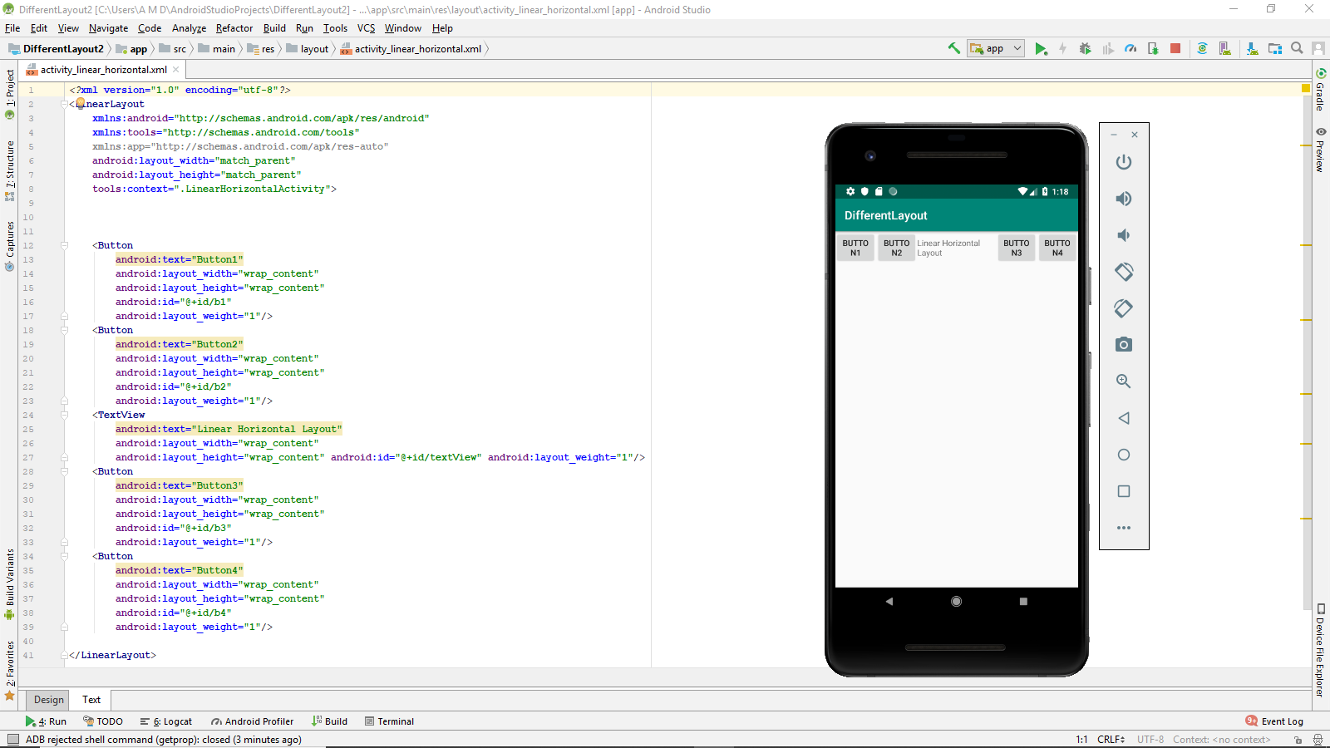

**activity_linear_vertical.xml**

<?xml version="1.0" encoding="utf-8"?>  
<LinearLayout  
 xmlns:android="http://schemas.android.com/apk/res/android"  
 xmlns:tools="http://schemas.android.com/tools"  
 xmlns:app="http://schemas.android.com/apk/res-auto"  
 android:layout_width="match_parent"  
 android:layout_height="match_parent"  
 android:orientation="vertical"  
 tools:context=".LinearVerticalActivity">  
 <TextView  
 android:text="Linear Layout Vertical"  
 android:layout_width="wrap_content"  
 android:layout_height="wrap_content"  
 android:textSize="100px"  
 />  
<Button  
 android:text="Button1"  
 android:layout_width="wrap_content"  
 android:layout_height="wrap_content"  
 android:id="@+id/b1"  
 />  
 <Button  
 android:text="Button2"  
 android:layout_width="wrap_content"  
 android:layout_height="wrap_content"  
 android:id="@+id/b2"  
 />  
 <Button  
 android:text="Button3"  
 android:layout_width="wrap_content"  
 android:layout_height="wrap_content"  
 android:id="@+id/b3"  
 />  
 <Button  
 android:text="Button4"  
 android:layout_width="wrap_content"  
 android:layout_height="wrap_content"  
 android:id="@+id/b4"  
 />  
</LinearLayout>

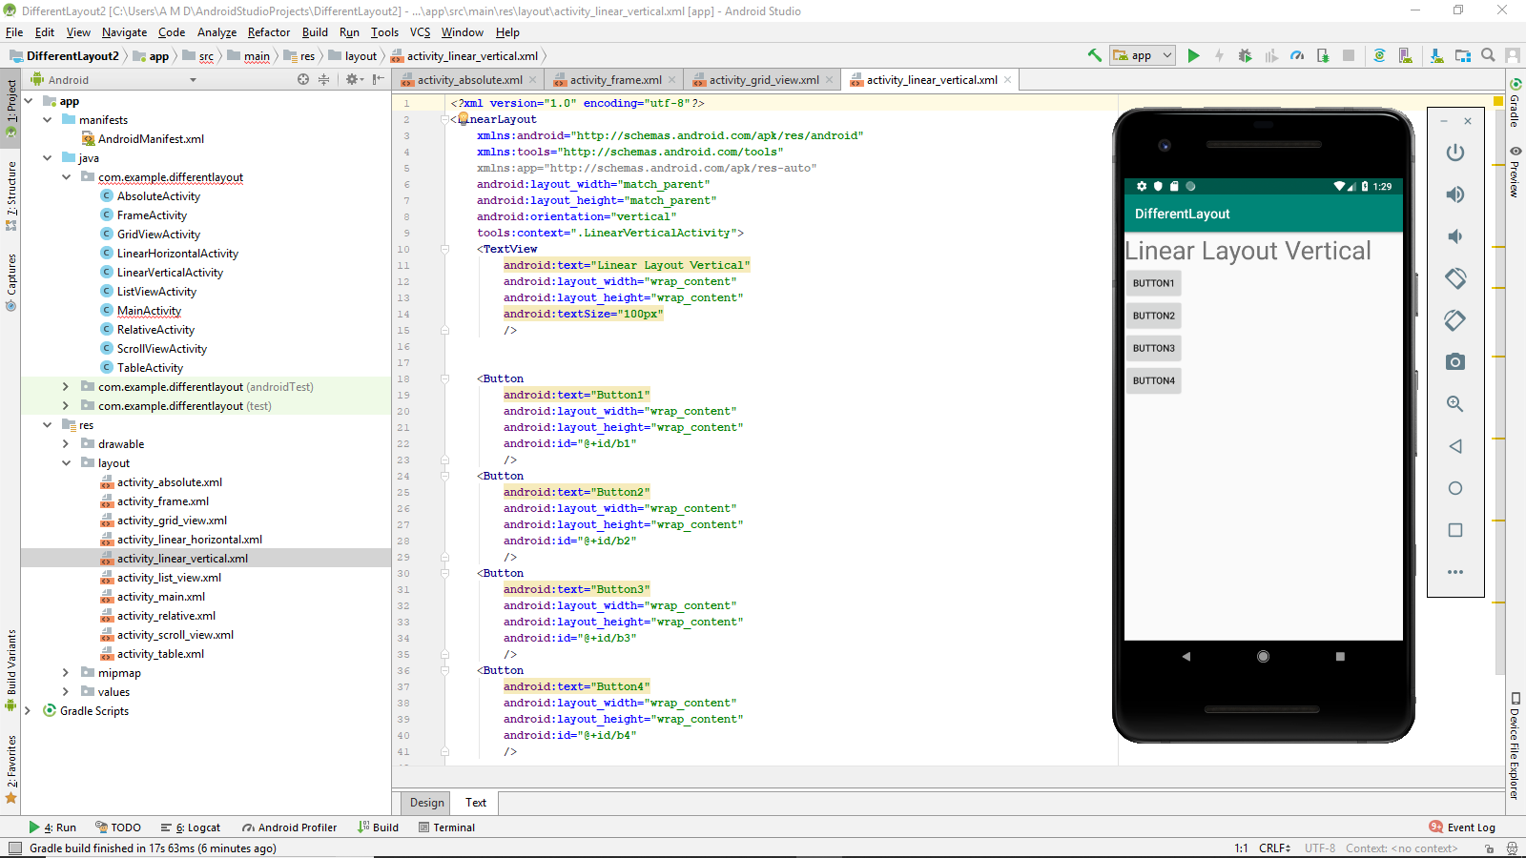

**activity_list_view.xml**

<?xml version="1.0" encoding="utf-8"?>  
<RelativeLayout  
 xmlns:android="http://schemas.android.com/apk/res/android"  
 xmlns:tools="http://schemas.android.com/tools"  
 xmlns:app="http://schemas.android.com/apk/res-auto"  
 android:layout_width="match_parent"  
 android:layout_height="match_parent"  
 tools:context=".ListViewActivity">  
 <TextView android:layout_width="wrap_content"  
 android:layout_height="wrap_content"  
 android:text="List View"  
 android:textSize="100px"  
 android:layout_alignParentTop="true"  
 android:layout_centerHorizontal="true"  
 android:id="@+id/tvt"  
 />  
 <ListView android:layout_width="wrap_content" android:layout_height="wrap_content"  
 android:layout_below="@+id/tvt"  
 android:id="@+id/lv"  
 >  
 </ListView>  
  
</RelativeLayout>

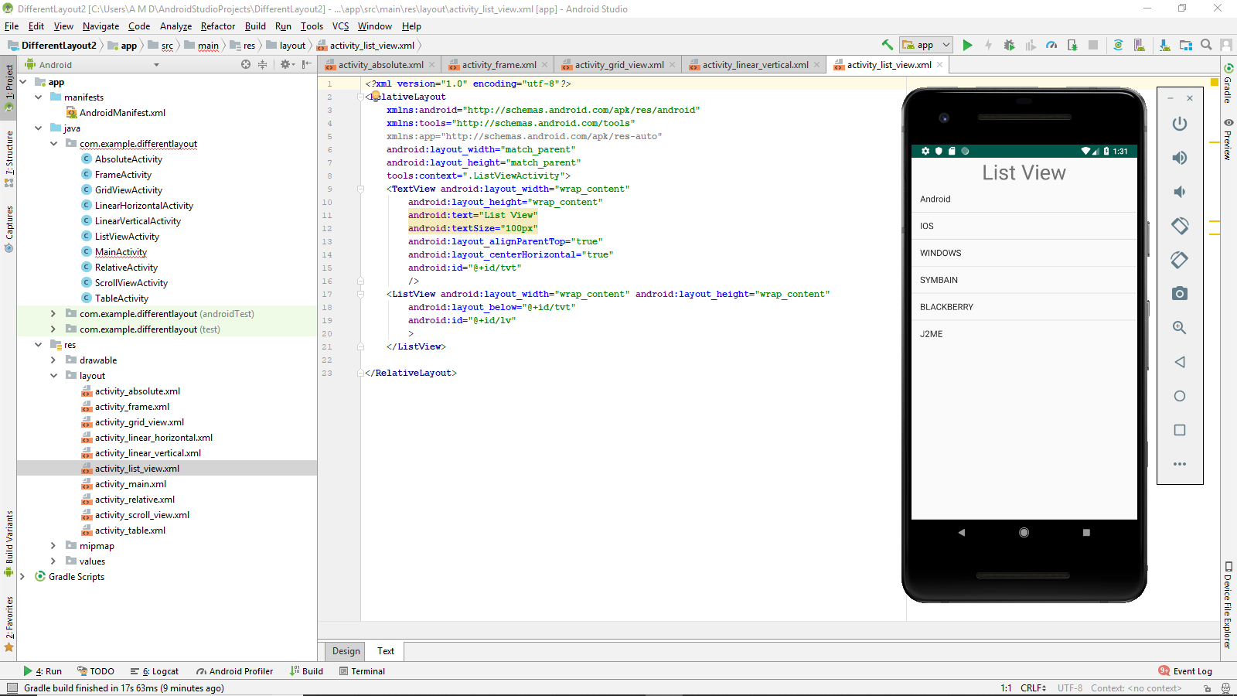

**activity_main.xml**

<?xml version="1.0" encoding="utf-8"?>  
<LinearLayout  
 xmlns:android="http://schemas.android.com/apk/res/android"  
 xmlns:tools="http://schemas.android.com/tools"  
 xmlns:app="http://schemas.android.com/apk/res-auto"  
 android:layout_width="match_parent"  
 android:layout_height="match_parent"  
 android:orientation="vertical"  
 tools:context=".MainActivity">  
  
 <TextView  
 android:layout_width="match_parent"  
 android:layout_height="wrap_content"  
 android:text="Layout Demonstration!"  
 android:layout_gravity="center"  
 android:textAlignment="center"  
 android:textSize="50px"  
 />  
 <Button android:layout_width="match_parent" android:layout_height="wrap_content"  
 android:text="Relative Layout"  
 android:layout_gravity="center"  
 android:id="@+id/btnrelative"  
 />  
 <Button android:layout_width="match_parent" android:layout_height="wrap_content"  
 android:text="Linear Layout (Horizontal)"  
 android:layout_gravity="center"  
 android:id="@+id/btnlinearH"  
 />  
 <Button android:layout_width="match_parent" android:layout_height="wrap_content"  
 android:text="Linera Layout (Vertical)"  
 android:layout_gravity="center"  
 android:id="@+id/btnLinearV"  
 />  
 <Button android:layout_width="match_parent" android:layout_height="wrap_content"  
 android:text="Table Layout"  
 android:layout_gravity="center"  
 android:id="@+id/btntable"  
 />  
 <Button android:layout_width="match_parent" android:layout_height="wrap_content"  
 android:text="Scroll Layout"  
 android:layout_gravity="center"  
 android:id="@+id/btnScroll"  
 />  
 <Button android:layout_width="match_parent" android:layout_height="wrap_content"  
 android:text="Absolute Layout"  
 android:layout_gravity="center"  
 android:id="@+id/btnabsolute"  
 />  
 <Button android:layout_width="match_parent" android:layout_height="wrap_content"  
 android:text="List Layout"  
 android:layout_gravity="center"  
 android:id="@+id/btnlist"  
 />  
 <Button android:layout_width="match_parent" android:layout_height="wrap_content"  
 android:text="Grid Layout"  
 android:layout_gravity="center"  
 android:id="@+id/btngrid"  
 />  
 <Button android:layout_width="match_parent" android:layout_height="wrap_content"  
 android:text="Frame Layout"  
 android:layout_gravity="center"  
 android:id="@+id/btnfeame"  
 />  
</LinearLayout>

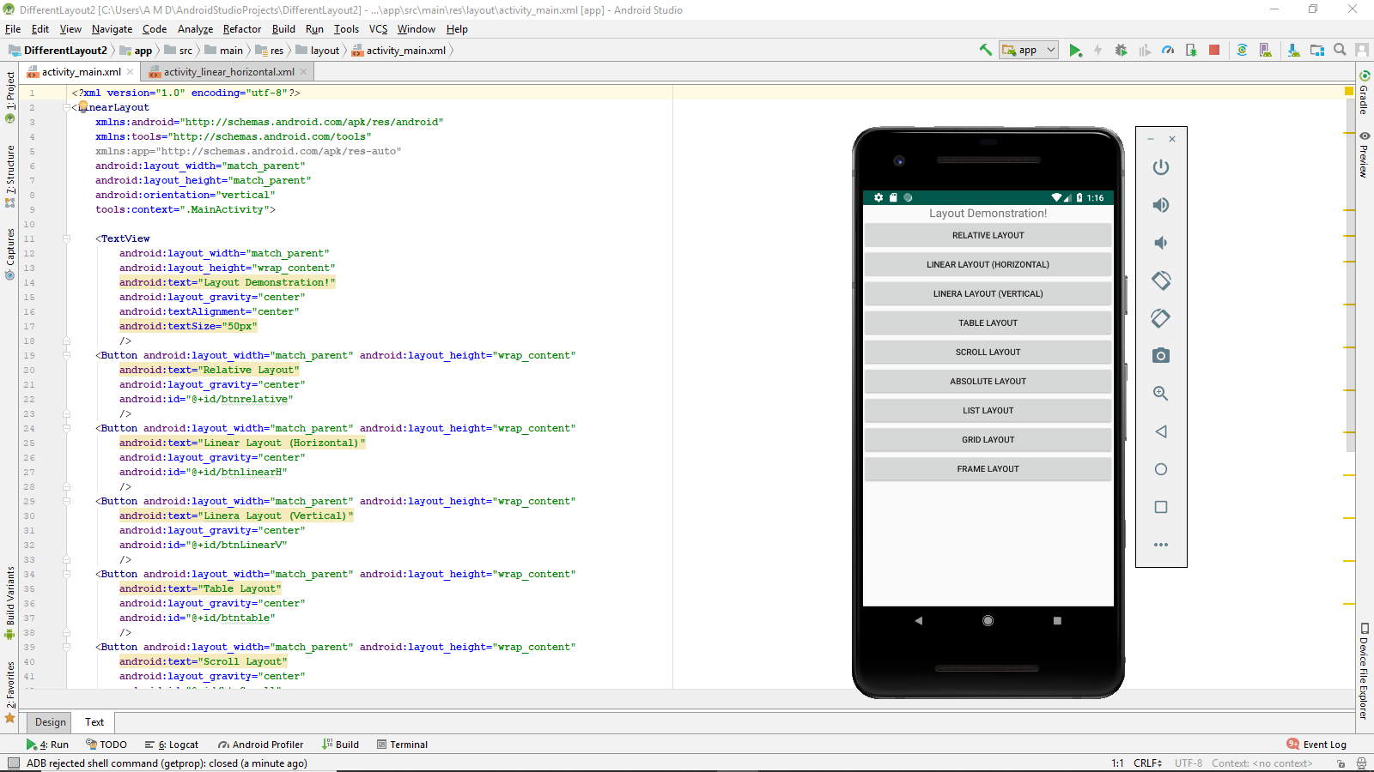

**activity_table.xml**

<?xml version="1.0" encoding="utf-8"?>  
<RelativeLayout  
 xmlns:android="http://schemas.android.com/apk/res/android"  
 xmlns:tools="http://schemas.android.com/tools"  
 xmlns:app="http://schemas.android.com/apk/res-auto"  
 android:layout_width="match_parent"  
 android:layout_height="match_parent"  
 tools:context=".RelativeActivity">  
  
 <TextView  
 android:text="Comments"  
 android:layout_alignParentTop="true"  
 android:layout_alignParentLeft="true"  
 android:layout_width="wrap_content"  
 android:layout_height="wrap_content"  
 android:id="@+id/lblcomments"/>  
  
 <EditText android:layout_width="fill_parent"  
 android:layout_height="170px"  
 android:id="@+id/txcomments"  
 android:textSize="18sp"  
 android:layout_alignParentLeft="@+id/lblcomments"  
 android:layout_below="@+id/lblcomments"  
 android:layout_centerHorizontal="true"/>  
 <Button android:layout_width="210px"  
 android:id="@+id/btnsave"  
 android:text="Save"  
 android:layout_below="@+id/txcomments"  
 android:layout_alignRight="@+id/txcomments"  
 android:layout_height="wrap_content"/>  
 <Button android:layout_width="210px"  
 android:id="@+id/btnCancel"  
 android:layout_below="@+id/txcomments"  
 android:layout_alignLeft="@id/txcomments"  
 android:text="Cancel"  
 android:layout_height="wrap_content"/>  
 <TextView  
 android:text="Relative Layout"  
 android:layout_width="match_parent"  
 android:textSize="100px"  
 android:layout_height="wrap_content"  
 android:textAlignment="center"  
 android:id="@+id/Relativelayout"  
 android:layout_centerHorizontal="true"  
 android:layout_centerVertical="true"  
 />  
</RelativeLayout>

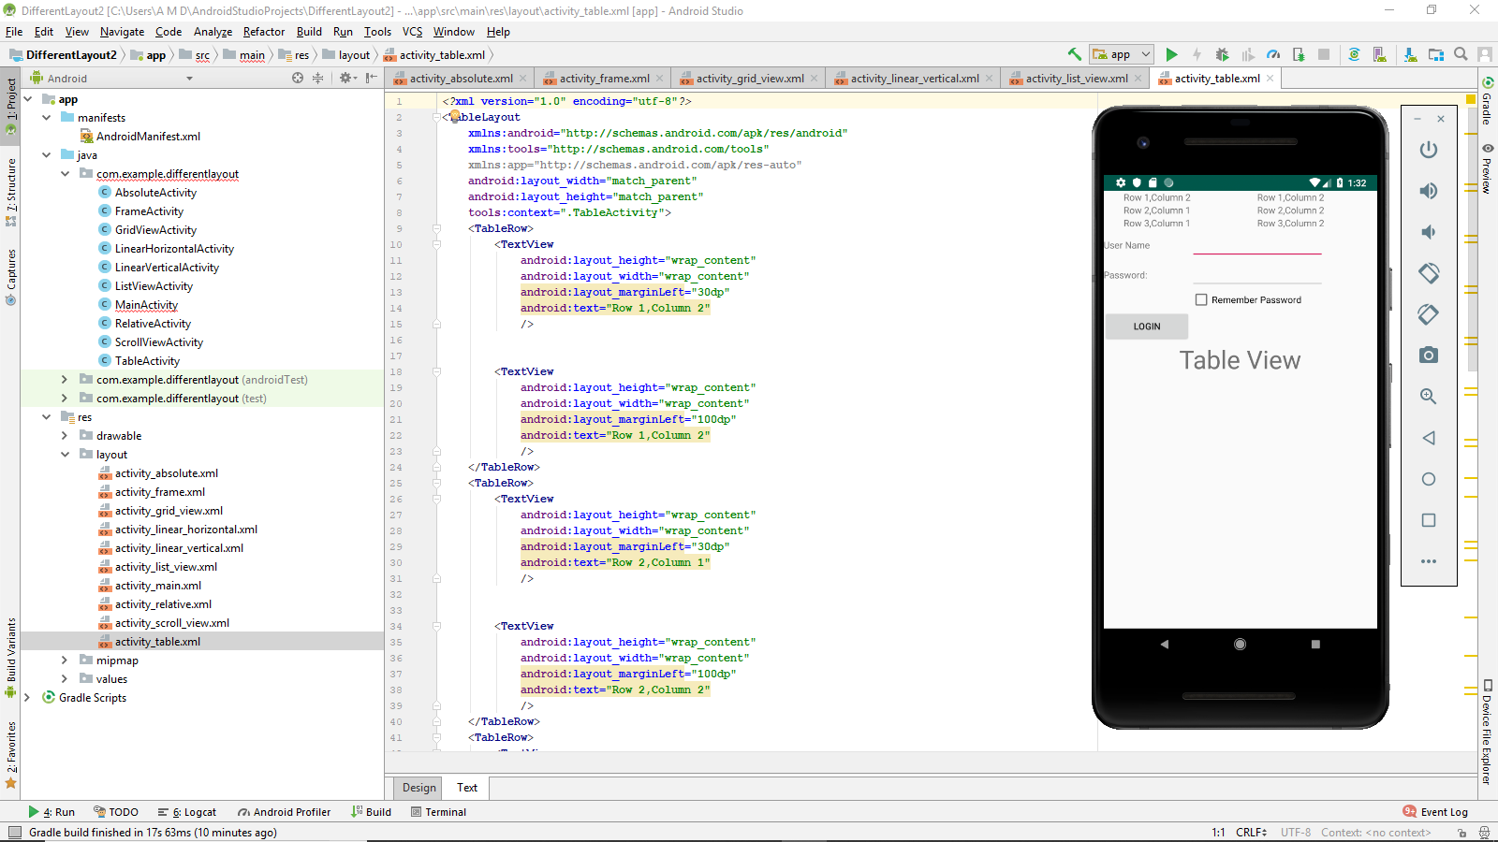

**Activity_scroll_view.xml**

<?xml version="1.0" encoding="utf-8"?>  
<ScrollView  
 xmlns:android="http://schemas.android.com/apk/res/android"  
 xmlns:tools="http://schemas.android.com/tools"  
 xmlns:app="http://schemas.android.com/apk/res-auto"  
 android:layout_width="match_parent"  
 android:layout_height="match_parent"  
 tools:context=".ScrollViewActivity">  
 <LinearLayout android:layout_width="wrap_content"  
 android:layout_height="wrap_content"  
 android:orientation="vertical"  
 >  
 <TextView android:layout_width="wrap_content" android:layout_height="wrap_content"  
 android:text="Line 1"  
 android:textSize="40dp"  
 />  
 <TextView android:layout_width="wrap_content" android:layout_height="wrap_content"  
 android:text="Line 2"  
 android:textSize="40dp"  
 />  
 <TextView android:layout_width="wrap_content" android:layout_height="wrap_content"  
 android:text="Line 3"  
 android:textSize="40dp"  
 />  
 <TextView android:layout_width="wrap_content" android:layout_height="wrap_content"  
 android:text="Line 4"  
 android:textSize="40dp"  
 />  
 <TextView android:layout_width="wrap_content" android:layout_height="wrap_content"  
 android:text="Line 5"  
 android:textSize="40dp"  
 />  
 <TextView android:layout_width="wrap_content" android:layout_height="wrap_content"  
 android:text="Line 6"  
 android:textSize="40dp"  
 />  
 <TextView android:layout_width="wrap_content" android:layout_height="wrap_content"  
 android:text="Line 7"  
 android:textSize="40dp"  
 />  
 <TextView android:layout_width="wrap_content" android:layout_height="wrap_content"  
 android:text="Line 8"  
 android:textSize="40dp"  
 />  
 <TextView android:layout_width="wrap_content" android:layout_height="wrap_content"  
 android:text="Line 9"  
 android:textSize="40dp"  
 />  
 <TextView android:layout_width="wrap_content" android:layout_height="wrap_content"  
 android:text="Line 10"  
 android:textSize="40dp"  
 />  
 <TextView android:layout_width="wrap_content" android:layout_height="wrap_content"  
 android:text="Line 11"  
 android:textSize="40dp"  
 />  
 <TextView android:layout_width="wrap_content" android:layout_height="wrap_content"  
 android:text="Line 12"  
 android:textSize="40dp"  
 />  
 <TextView android:layout_width="wrap_content" android:layout_height="wrap_content"  
 android:text="Line 13"  
 android:textSize="40dp"  
 />  
 <TextView android:layout_width="wrap_content" android:layout_height="wrap_content"  
 android:text="Line 14"  
 android:textSize="40dp"  
 />  
 <TextView android:layout_width="wrap_content"

android:layout_height="wrap_content"  
 android:text="Line 15"  
 android:textSize="40dp"  
 />  
 <TextView android:layout_width="wrap_content" android:layout_height="wrap_content"  
 android:text="Line 16"  
 android:textSize="40dp"  
 />  
 <TextView android:layout_width="wrap_content" android:layout_height="wrap_content"  
 android:text="Line 17"  
 android:textSize="40dp"  
 />  
 <TextView android:layout_width="wrap_content" android:layout_height="wrap_content"  
 android:text="Line 18"  
 android:textSize="40dp"  
 />  
 <TextView android:layout_width="wrap_content" android:layout_height="wrap_content"  
 android:text="Line 19"  
 android:textSize="40dp"  
 />  
 <TextView android:layout_width="wrap_content" android:layout_height="wrap_content"  
 android:text="Line 20"  
 android:textSize="40dp"  
 />  
  
  
 </LinearLayout>  
  
</ScrollView>

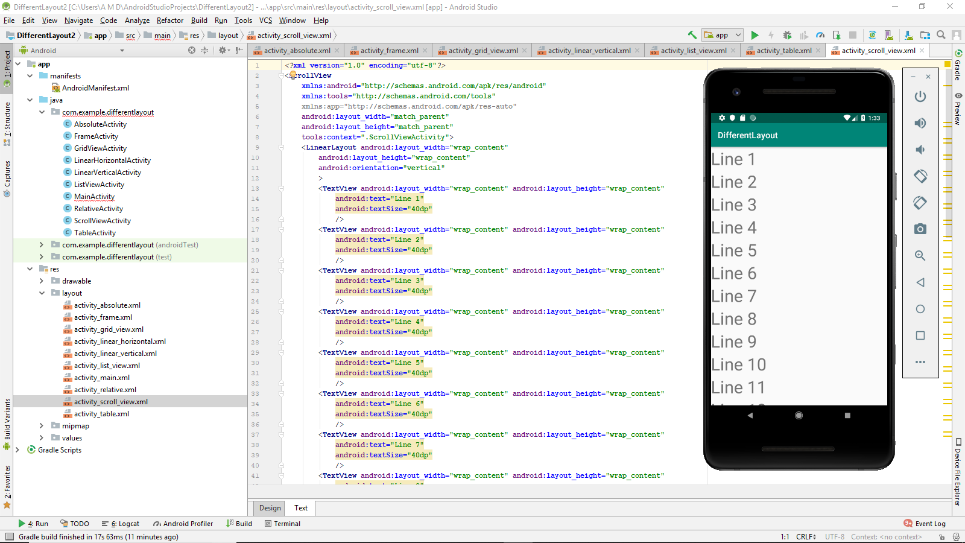

**Activity_relative.xml**

<?xml version="1.0" encoding="utf-8"?>  
<RelativeLayout  
 xmlns:android="http://schemas.android.com/apk/res/android"  
 xmlns:tools="http://schemas.android.com/tools"  
 xmlns:app="http://schemas.android.com/apk/res-auto"  
 android:layout_width="match_parent"  
 android:layout_height="match_parent"  
 tools:context=".RelativeActivity">  
  
 <TextView  
 android:text="Comments"  
 android:layout_alignParentTop="true"  
 android:layout_alignParentLeft="true"  
 android:layout_width="wrap_content"  
 android:layout_height="wrap_content"  
 android:id="@+id/lblcomments"/>  
  
 <EditText android:layout_width="fill_parent"  
 android:layout_height="170px"  
 android:id="@+id/txcomments"  
 android:textSize="18sp"  
 android:layout_alignParentLeft="@+id/lblcomments"  
 android:layout_below="@+id/lblcomments"  
 android:layout_centerHorizontal="true"/>  
 <Button android:layout_width="210px"  
 android:id="@+id/btnsave"  
 android:text="Save"  
 android:layout_below="@+id/txcomments"  
 android:layout_alignRight="@+id/txcomments"  
 android:layout_height="wrap_content"/>  
 <Button android:layout_width="210px"  
 android:id="@+id/btnCancel"  
 android:layout_below="@+id/txcomments"  
 android:layout_alignLeft="@id/txcomments"  
 android:text="Cancel"  
 android:layout_height="wrap_content"/>  
 <TextView  
 android:text="Relative Layout"  
 android:layout_width="match_parent"  
 android:textSize="100px"  
 android:layout_height="wrap_content"  
 android:textAlignment="center"  
 android:id="@+id/Relativelayout"  
 android:layout_centerHorizontal="true"  
 android:layout_centerVertical="true"  
 />  
</RelativeLayout>

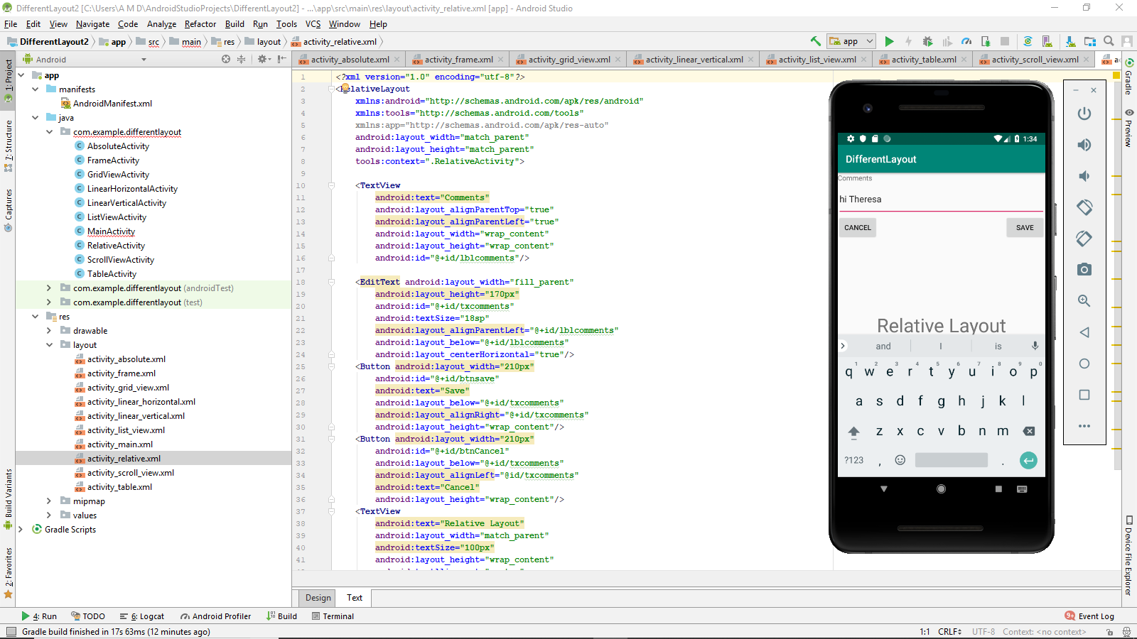

**AbsoluteActivity.java**

package com.example.differentlayout;  
  
import android.support.v7.app.AppCompatActivity;  
import android.os.Bundle;  
  
public class AbsoluteActivity extends AppCompatActivity {  
  
 @Override  
 protected void onCreate(Bundle savedInstanceState) {  
 super.onCreate(savedInstanceState);  
 setContentView(R.layout.*activity_absolute*);  
 }  
}

**FrameActivity.java**

package com.example.differentlayout;  
  
import android.support.v7.app.AppCompatActivity;  
import android.os.Bundle;  
  
public class FrameActivity extends AppCompatActivity {  
  
 @Override  
 protected void onCreate(Bundle savedInstanceState) {  
 super.onCreate(savedInstanceState);  
 setContentView(R.layout.*activity_frame*);  
 }  
}

**LinearHorizontalActivity.java**

package com.example.differentlayout;  
  
import android.support.v7.app.AppCompatActivity;  
import android.os.Bundle;  
  
public class LinearHorizontalActivity extends AppCompatActivity {  
  
 @Override  
 protected void onCreate(Bundle savedInstanceState) {  
 super.onCreate(savedInstanceState);  
 setContentView(R.layout.*activity_linear_horizontal*);  
 }  
}

**LinearVerticalActivity.java**

package com.example.differentlayout;  
  
import android.support.v7.app.AppCompatActivity;  
import android.os.Bundle;  
  
public class LinearVerticalActivity extends AppCompatActivity {  
  
 @Override  
 protected void onCreate(Bundle savedInstanceState) {  
 super.onCreate(savedInstanceState);  
 setContentView(R.layout.*activity_linear_vertical*);  
 }  
}

**GridViewActivity.java**

package com.example.differentlayout;  
  
import android.app.Activity;  
import android.content.Context;  
import android.support.v7.app.AppCompatActivity;  
import android.os.Bundle;  
import android.view.View;  
import android.view.ViewGroup;  
import android.widget.*;  
  
class GridViewActivity extends Activity{  
 Integer [] imageIDs={  
 R.mipmap.*ic_launcher*,  
 R.mipmap.*ic_launcher*,  
 R.mipmap.*ic_launcher*,  
 R.mipmap.*ic_launcher*,  
 R.mipmap.*ic_launcher*,  
 R.mipmap.*ic_launcher*,  
 R.mipmap.*ic_launcher* };  
  
 @Override  
 protected void onCreate(Bundle savedInstanceState) {  
 super.onCreate(savedInstanceState);  
 setContentView(R.layout.*activity_grid_view*);  
 GridView gridView=(GridView)findViewById(R.id.*gridview*);  
 gridView.setOnItemClickListener(new AdapterView.OnItemClickListener() {  
 @Override  
 public void onItemClick(AdapterView<?> parent, View view, int position, long id) {  
 Toast.*makeText*(getBaseContext(),"pic"+(position+1)+"selected",Toast.*LENGTH_LONG*).show();  
 }  
 });  
 }  
 public class ImageAdapter extends BaseAdapter{  
 private Context context;  
  
 public ImageAdapter(Context c) {  
 context = c;  
 }  
  
 //returns the number of images  
 public int getCount(){  
 return imageIDs.length;  
 }  
  
 @Override  
 public Object getItem(int position) {  
 return null;  
 }  
  
 @Override  
 public long getItemId(int position) {  
 return 0;  
 }  
  
 //return the iteam  
 public Object getIteam(int position){  
 return position;  
 }  
 //returs id of the iteam  
 public long getIteamId(int position){  
 return position;  
  
 }  
 //return and image view  
 public View getView(int position, View convertView, ViewGroup parent) {  
 ImageView imageView;  
 if(convertView==null){  
 imageView=new ImageView(context);  
 imageView.setLayoutParams(new GridView.LayoutParams(85,85));  
 imageView.setScaleType(ImageView.ScaleType.*CENTER_CROP*);  
 imageView.setPadding(5,5,5,5);  
  
 }  
 else{  
 imageView=(ImageView)convertView;  
 }  
 imageView.setImageResource(imageIDs[position]);  
 return imageView;  
 }  
  
  
 }  
}

**RelativeActivity.java**

package com.example.differentlayout;  
  
import android.support.v7.app.AppCompatActivity;  
import android.os.Bundle;  
  
public class RelativeActivity extends AppCompatActivity {  
  
 @Override  
 protected void onCreate(Bundle savedInstanceState) {  
 super.onCreate(savedInstanceState);  
 setContentView(R.layout.*activity_relative*);  
 }  
}

**ScrollViewActivity.java**

package com.example.differentlayout;  
  
import android.support.v7.app.AppCompatActivity;  
import android.os.Bundle;  
  
public class ScrollViewActivity extends AppCompatActivity {  
  
 @Override  
 protected void onCreate(Bundle savedInstanceState) {  
 super.onCreate(savedInstanceState);  
 setContentView(R.layout.*activity_scroll_view*);  
 }  
}

**ListViewActivity.java**

package com.example.differentlayout;  
  
import android.app.Activity;  
import android.support.v7.app.AppCompatActivity;  
import android.os.Bundle;  
import android.view.View;  
import android.widget.AdapterView;  
import android.widget.ArrayAdapter;  
import android.widget.ListView;  
import android.widget.Toast;  
  
public class ListViewActivity extends Activity{  
 ListView l;  
  
 @Override  
 protected void onCreate(Bundle savedInstanceState) {  
 super.onCreate(savedInstanceState);  
 setContentView(R.layout.*activity_list_view*);  
 final String [] s={"Android","IOS","WINDOWS","SYMBAIN","BLACKBERRY","J2ME"};  
 setContentView(R.layout.*activity_list_view*);  
 l=(ListView)findViewById(R.id.*lv*);  
 ArrayAdapter ada=new ArrayAdapter(ListViewActivity.this,android.R.layout.*simple_list_item_1*,s);  
 l.setAdapter(ada);  
 l.setOnItemClickListener(new AdapterView.OnItemClickListener() {  
 @Override  
 public void onItemClick(AdapterView<?> parent, View view, int position, long id) {  
 Toast.*makeText*(ListViewActivity.this,"Iteam Clicked"+position,Toast.*LENGTH_LONG*).show();  
 Toast.*makeText*(ListViewActivity.this,"Iteam:"+s[position],Toast.*LENGTH_LONG*).show();  
 }  
 });  
 }  
}

**TableActivity.java**

package com.example.differentlayout;  
  
import android.app.Activity;  
import android.support.v7.app.AppCompatActivity;  
import android.os.Bundle;  
  
import com.example.differentlayout.R;  
  
class TableActivity extends Activity{  
 @Override  
 protected void onCreate(Bundle savedInstanceState) {  
 super.onCreate(savedInstanceState);  
 setContentView(R.layout.*activity_table*);  
 }

**MainActivity.java**

package com.example.differentlayout;  
  
import android.app.Activity;  
import android.content.Intent;  
import android.support.v7.app.AppCompatActivity;  
import android.os.Bundle;  
import android.view.View;  
import android.widget.Button;  
  
public class MainActivity extends Activity{  
 @Override  
 protected void onCreate(Bundle savedInstanceState) {  
 super.onCreate(savedInstanceState);  
 setContentView(R.layout.*activity_main*);  
 Button btnrelative=(Button)findViewById(R.id.*btnrelative*);  
 final Button btnlinearH=(Button)findViewById(R.id.*btnlinearH*);  
 Button btnlinearV=(Button)findViewById(R.id.*btnLinearV*);  
 Button btntable=(Button)findViewById(R.id.*btntable*);  
 Button btnrscrollv=(Button)findViewById(R.id.*btnScroll*);  
 Button btnabsolute=(Button)findViewById(R.id.*btnabsolute*);  
 Button btnlist=(Button)findViewById(R.id.*btnlist*);  
 Button btngrid=(Button)findViewById(R.id.*btngrid*);  
 Button btnframe=(Button)findViewById(R.id.*btnfeame*);  
 btnrelative.setOnClickListener(new View.OnClickListener() {  
 @Override  
 public void onClick(View v) {  
 Intent i=new Intent(getApplicationContext(),RelativeActivity.class);  
 startActivity(i);  
 }  
 });  
 btnlinearH.setOnClickListener(new View.OnClickListener() {  
 @Override  
 public void onClick(View v) {  
 Intent i= new Intent(getApplicationContext(),LinearHorizontalActivity.class);  
 startActivity(i);  
 }  
 });  
 btnlinearV.setOnClickListener(new View.OnClickListener() {  
 @Override  
 public void onClick(View v) {  
 Intent i= new Intent(getApplicationContext(),LinearVerticalActivity.class);  
 startActivity(i);  
 }  
 });  
 btntable.setOnClickListener(new View.OnClickListener() {  
 @Override  
 public void onClick(View v) {  
 Intent i= new Intent(getApplicationContext(),TableActivity.class);  
 startActivity(i);  
 }  
 });  
 btnrscrollv.setOnClickListener(new View.OnClickListener() {  
 @Override  
 public void onClick(View v) {  
 Intent i= new Intent(getApplicationContext(),ScrollViewActivity.class);  
 startActivity(i);  
 }  
 });  
 btnabsolute.setOnClickListener(new View.OnClickListener() {  
 @Override  
 public void onClick(View v) {  
 Intent i= new Intent(getApplicationContext(),AbsoluteActivity.class);  
 startActivity(i);  
 }  
 });  
 btnlist.setOnClickListener(new View.OnClickListener() {  
 @Override  
 public void onClick(View v) {  
 Intent i= new Intent(getApplicationContext(),ListViewActivity.class);  
 startActivity(i);  
 }  
 });  
 btngrid.setOnClickListener(new View.OnClickListener() {  
 @Override  
 public void onClick(View v) {  
 Intent i= new Intent(getApplicationContext(),GridViewActivity.class);  
 startActivity(i);  
 }  
 });  
 btnframe.setOnClickListener(new View.OnClickListener() {  
 @Override  
 public void onClick(View v) {  
 Intent i= new Intent(getApplicationContext(),FrameActivity.class);  
 startActivity(i);  
 }  
 });  
  
 }  
}

**AndroidManifest.xml**

<?xml version="1.0" encoding="utf-8"?>  
<manifest xmlns:android="http://schemas.android.com/apk/res/android"  
 package="com.example.differentlayout">  
  
 <application  
 android:allowBackup="true"  
 android:icon="@mipmap/ic_launcher"  
 android:label="@string/app_name"  
 android:roundIcon="@mipmap/ic_launcher_round"  
 android:supportsRtl="true"  
 android:theme="@style/AppTheme">  
 <activity  
 android:name=".TableActivity"  
 android:label="@string/title_activity_table"  
 android:theme="@style/AppTheme.NoActionBar"></activity>  
 <activity android:name=".ScrollViewActivity" />  
 <activity android:name=".ListViewActivity" />  
 <activity android:name=".LinearVerticalActivity" />  
 <activity android:name=".LinearHorizontalActivity" />  
 <activity android:name=".GridViewActivity" />  
 <activity android:name=".RelativeActivity" />  
 <activity android:name=".FrameActivity" />  
 <activity android:name=".AbsoluteActivity" />  
 <activity android:name=".MainActivity">  
 <intent-filter>  
 <action android:name="android.intent.action.MAIN" />  
  
 <category android:name="android.intent.category.LAUNCHER" />  
 </intent-filter>  
 </activity>  
 </application>  
  
</manifest>

**PRACTICAL 5**

Programming UI elements

1. Creating App Bar
2. First remove the default action bar

Go to res🡺 values🡺styles.xml

Change the following line 🡺<**stylename="AppTheme"parent="Theme.AppCompat.Light.DarkActionBar"**>

To

🡺<**style name="AppTheme" parent="Theme.AppCompat.Light.NoActionBar"**>

1. Add New Layout

Go to res🡺layout

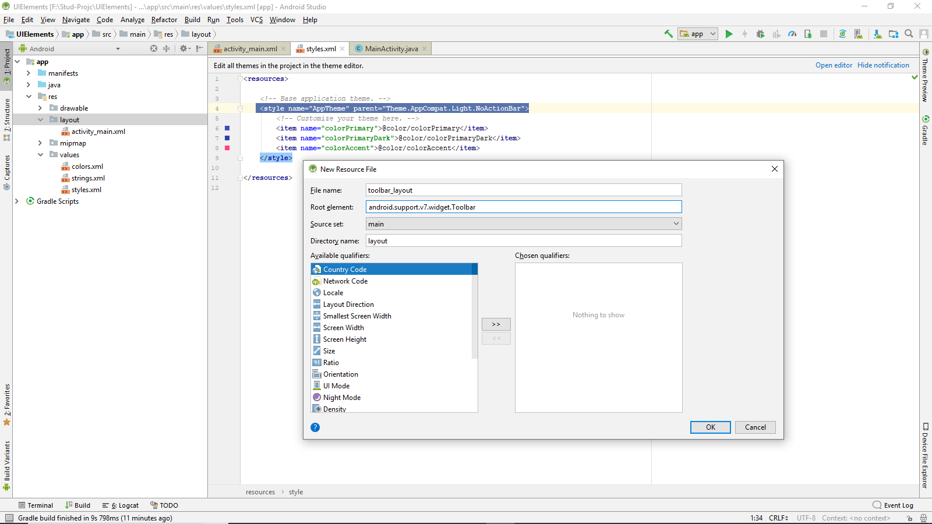

Add following code in toolbar_layout.xml

*<?***xml version="1.0" encoding="utf-8"***?>*<**android.support.v7.widget.Toolbar xmlns:android="http://schemas.android.com/apk/res/android"  
 android:layout_width="match_parent"  
 android:layout_height="?attr/actionBarSize"  
 xmlns:app="http://schemas.android.com/apk/res-auto"  
 android:background="?attr/colorPrimary"  
 android:theme="@style/ThemeOverlay.AppCompat.Dark.ActionBar"  
 app:popupTheme="@style/ThemeOverlay.AppCompat.Light"  
 android:id="@+id/toolBar"** >  
</**android.support.v7.widget.Toolbar**>

Add following code in activity_main.xml

*<?***xml version="1.0" encoding="utf-8"***?>*<**LinearLayout xmlns:android="http://schemas.android.com/apk/res/android"  
 xmlns:app="http://schemas.android.com/apk/res-auto"  
 xmlns:tools="http://schemas.android.com/tools"  
 android:layout_width="match_parent"  
 android:layout_height="match_parent"  
 tools:context=".MainActivity"  
 android:orientation="vertical"** >  
 <**include  
 layout="@layout/toolbar_layout"**/>  
</**LinearLayout**>

Setting the toolbar as the default action bar

Write the following code in MainActivity.java

**package** com.example.amd.uielements;  
  
**import** android.support.v7.app.AppCompatActivity;  
**import** android.os.Bundle;  
**import** android.support.v7.widget.Toolbar;  
  
**public class** MainActivity **extends** AppCompatActivity {  
 **private** android.support.v7.widget.Toolbar **tbar**;  
  
 @Override  
 **protected void** onCreate(Bundle savedInstanceState) {  
 **super**.onCreate(savedInstanceState);  
 setContentView(R.layout.***activity_main***);  
 **tbar**=findViewById(R.id.***toolBar***);  
 setSupportActionBar(**tbar**);  
 }  
}

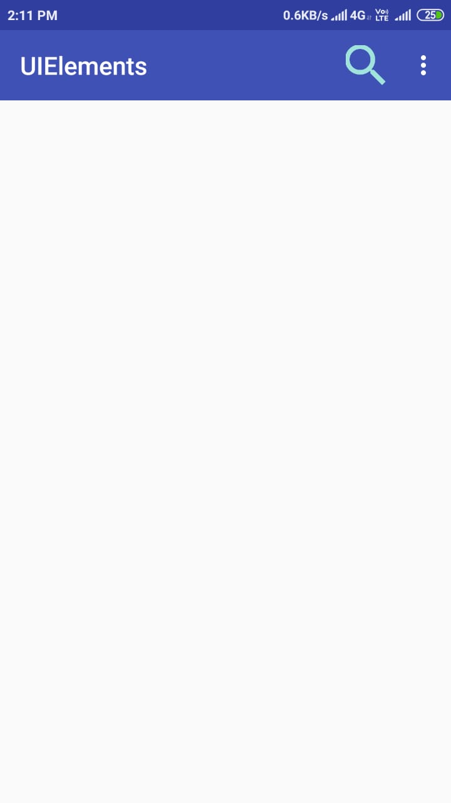

1. Add Menu to App Bar

Download sample icons from material.io/tools/icons and paste it into mipmap

Or

Rename layer name to ic_settings click on the icon in front of clip art to choose amongst following icons

Res🡺new🡺app_bar_menu

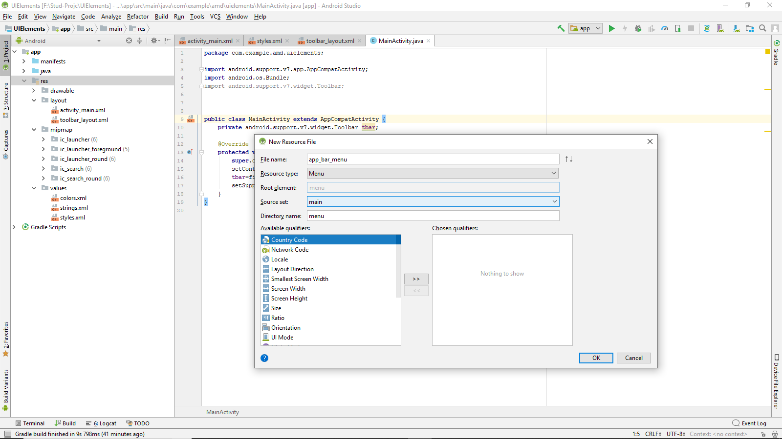

Write the following code in app_bar_menu.xml

*<?***xml version="1.0" encoding="utf-8"***?>*<**menu xmlns:android="http://schemas.android.com/apk/res/android"  
 xmlns:app="http://schemas.android.com/apk/res-auto"**>  
 <**item  
 android:id="@+id/action_search"  
 android:title="Setting"  
 android:icon="@mipmap/ic_Settings"  
 app:showAsAction="ifRoom"** />  
 <**item  
 android:id="@+id/action_about"  
 android:title="About"  
 app:showAsAction="never"** />  
</**menu**>

To add this menu in app bar add the following code in MainActivity.java

**package** com.example.amd.uielements;  
  
**import** android.support.v7.app.AppCompatActivity;  
**import** android.os.Bundle;  
**import** android.support.v7.widget.Toolbar;  
**import** android.view.Menu;  
**import** android.view.MenuInflater;  
**import** android.view.MenuItem;  
**import** android.widget.Toast;  
**public class** MainActivity **extends** AppCompatActivity {  
 **private** android.support.v7.widget.Toolbar **tbar**;  
 @Override  
 **protected void** onCreate(Bundle savedInstanceState) {  
 **super**.onCreate(savedInstanceState);  
 setContentView(R.layout.***activity_main***);  
 **tbar**=findViewById(R.id.***toolBar***);  
 setSupportActionBar(**tbar**);  
 }  
 @Override  
 **public boolean** onCreateOptionsMenu(Menu menu) {  
 MenuInflater mi=getMenuInflater();  
 mi.inflate(R.menu.***app_bar_menu***,menu);  
 **return true**;  
 }  
 @Override  
 **public boolean** onOptionsItemSelected(MenuItem item) {  
 **switch** (item.getItemId()){  
 **case** R.id.***action_search***:  
 Toast.*makeText*(**this**,**"Search menu is clicked"**,Toast.***LENGTH_LONG***).show();  
 **return true**;  
 **case** R.id.***action_about***:  
 Toast.*makeText*(**this**,**"About menun s clicked"**,Toast.***LENGTH_LONG***).show();  
 **return true**;  
 **default**:  
 **return super**.onOptionsItemSelected(item);  
 }  
 }  
}

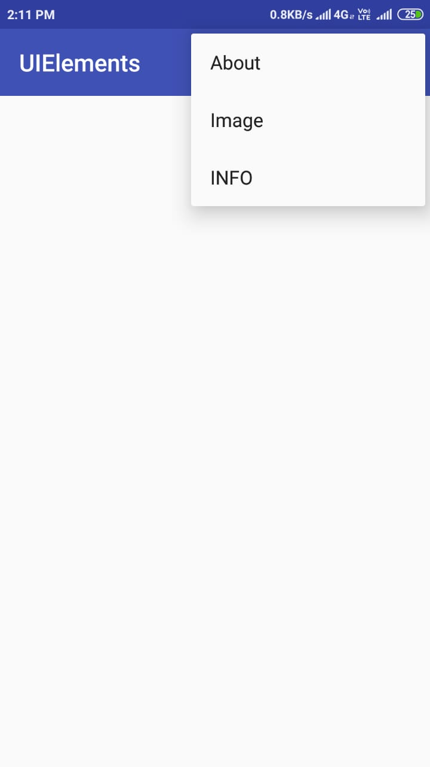

1. Fragment

Activity_main.xml

*<?***xml version="1.0" encoding="utf-8"***?>*<**LinearLayout xmlns:android="http://schemas.android.com/apk/res/android"  
 xmlns:app="http://schemas.android.com/apk/res-auto"  
 xmlns:tools="http://schemas.android.com/tools"  
 android:layout_width="match_parent"  
 android:layout_height="match_parent"  
 android:orientation="vertical"  
 android:layout_gravity="center_horizontal"  
 android:padding="16dp"  
 tools:context=".MainActivity"**>  
  
 <**FrameLayout  
 android:id="@+id/container_a"  
 android:layout_width="match_parent"  
 android:layout_height="wrap_content"** />  
  
 <**FrameLayout  
 android:id="@+id/container_b"  
 android:layout_width="match_parent"  
 android:layout_height="wrap_content"** />  
  
</**LinearLayout**>

Fragment_a.xml

*<?***xml version="1.0" encoding="utf-8"***?>*<**LinearLayout xmlns:android="http://schemas.android.com/apk/res/android"  
 android:orientation="vertical" android:layout_width="match_parent"  
 android:layout_height="match_parent"  
 android:gravity="center_horizontal"  
 android:background="@color/holo_green"  
 android:padding="16dp"** >  
 <**EditText  
 android:id="@+id/edit_text"  
 android:layout_width="match_parent"  
 android:layout_height="wrap_content"** />  
  
 <**Button  
 android:id="@+id/button_ok"  
 android:layout_width="wrap_content"  
 android:layout_height="wrap_content"  
 android:text="Ok"** />  
  
</**LinearLayout**>

Fragment_b.xml

*<?***xml version="1.0" encoding="utf-8"***?>*<**LinearLayout  
 xmlns:android="http://schemas.android.com/apk/res/android"  
 android:layout_width="match_parent"  
 android:layout_height="match_parent"  
 android:gravity="center_horizontal"  
 android:padding="16dp"  
 android:orientation="vertical"  
 android:background="@color/colorPrimary"** >  
  
 <**EditText  
 android:id="@+id/edit_text"  
 android:layout_width="match_parent"  
 android:layout_height="wrap_content"** />  
 <**Button  
 android:id="@+id/button_ok"  
 android:layout_width="wrap_content"  
 android:layout_height="wrap_content"  
 android:text="Ok"**/>  
  
</**LinearLayout**>

FragmentA.java

**package** com.example.amd.fragmentation;  
  
**import** android.content.Context;  
**import** android.os.Bundle;  
**import** android.support.annotation.Nullable;  
**import** android.support.v4.app.Fragment;  
**import** android.view.LayoutInflater;  
**import** android.view.View;  
**import** android.view.ViewGroup;  
**import** android.widget.Button;  
**import** android.widget.EditText;  
  
  
**public class** FragmentA **extends** Fragment {  
 **private** FragmentAListener **listener**;  
 **private** EditText **editText**;  
 **private** Button **buttonOk**;  
  
 **public interface** FragmentAListener {  
 **void** onInputASent(CharSequence input);  
 }  
  
 @Nullable  
 @Override  
 **public** View onCreateView(LayoutInflater inflater, @Nullable ViewGroup container, @Nullable Bundle savedInstanceState) {  
 View v = inflater.inflate(R.layout.***fragment_a***, container, **false**);  
  
 **editText** = v.findViewById(R.id.***edit_text***);  
 **buttonOk** = v.findViewById(R.id.***button_ok***);  
 **buttonOk**.setOnClickListener(**new** View.OnClickListener() {  
 @Override  
 **public void** onClick(View v) {  
 CharSequence input = **editText**.getText();  
 **listener**.onInputASent(input);  
 }  
 });  
  
 **return** v;  
 }  
  
 **public void** updateEditText(CharSequence newText) {  
 **editText**.setText(newText);  
 }  
  
 @Override  
 **public void** onAttach(Context context) {  
 **super**.onAttach(context);  
 **if** (context **instanceof** FragmentAListener) {  
 **listener** = (FragmentAListener) context;  
 } **else** {  
 **throw new** RuntimeException(context.toString()  
 + **" must implement FragmentAListener"**);  
 }  
 }  
  
 @Override  
 **public void** onDetach() {  
 **super**.onDetach();  
 **listener** = **null**;  
 }  
}

FragmentB.java

**package** com.example.amd.fragmentation;  
  
**import** android.content.Context;  
**import** android.os.Bundle;  
**import** android.support.annotation.Nullable;  
**import** android.support.v4.app.Fragment;  
**import** android.view.LayoutInflater;  
**import** android.view.View;  
**import** android.view.ViewGroup;  
**import** android.widget.Button;  
**import** android.widget.EditText;  
  
**public class** FragmentB **extends** Fragment {  
 **private** FragmentBListener **listener**;  
 **private** EditText **editText**;  
 **private** Button **buttonOk**;  
  
 **public interface** FragmentBListener {  
 **void** onInputBSent(CharSequence input);  
 }  
  
 @Nullable  
 @Override  
 **public** View onCreateView(LayoutInflater inflater, @Nullable ViewGroup container, @Nullable Bundle savedInstanceState) {  
 View v = inflater.inflate(R.layout.***fragment_b***, container, **false**);  
  
 **editText** = v.findViewById(R.id.***edit_text***);  
 **buttonOk** = v.findViewById(R.id.***button_ok***);  
 **buttonOk**.setOnClickListener(**new** View.OnClickListener() {  
 @Override  
 **public void** onClick(View v) {  
 CharSequence input = **editText**.getText();  
 **listener**.onInputBSent(input);  
 }  
 });  
  
 **return** v;  
 }  
  
 **public void** updateEditText(CharSequence newText) {  
 **editText**.setText(newText);  
 }  
  
 @Override  
 **public void** onAttach(Context context) {  
 **super**.onAttach(context);  
 **if** (context **instanceof** FragmentBListener) {  
 **listener** = (FragmentBListener) context;  
 } **else** {  
 **throw new** RuntimeException(context.toString()  
 + **" must implement FragmentBListener"**);  
 }  
 }  
  
 @Override  
 **public void** onDetach() {  
 **super**.onDetach();  
 **listener** = **null**;  
 }  
}

MainActivity.java

**package** com.example.amd.fragmentation;  
  
**import** android.support.v7.app.AppCompatActivity;  
**import** android.os.Bundle;  
  
**public class** MainActivity **extends** AppCompatActivity **implements** FragmentA.FragmentAListener, FragmentB.FragmentBListener {  
 **private** FragmentA **fragmentA**;  
 **private** FragmentB **fragmentB**;  
  
 @Override  
 **protected void** onCreate(Bundle savedInstanceState) {  
 **super**.onCreate(savedInstanceState);  
 setContentView(R.layout.***activity_main***);  
  
 **fragmentA** = **new** FragmentA();  
 **fragmentB** = **new** FragmentB();  
  
 getSupportFragmentManager().beginTransaction()  
 .replace(R.id.***container_a***, **fragmentA**)  
 .replace(R.id.***container_b***, **fragmentB**)  
 .commit();  
 }  
  
 @Override  
 **public void** onInputASent(CharSequence input) {  
 **fragmentB**.updateEditText(input);  
 }  
  
 @Override  
 **public void** onInputBSent(CharSequence input) {  
 **fragmentA**.updateEditText(input);  
 }  
}

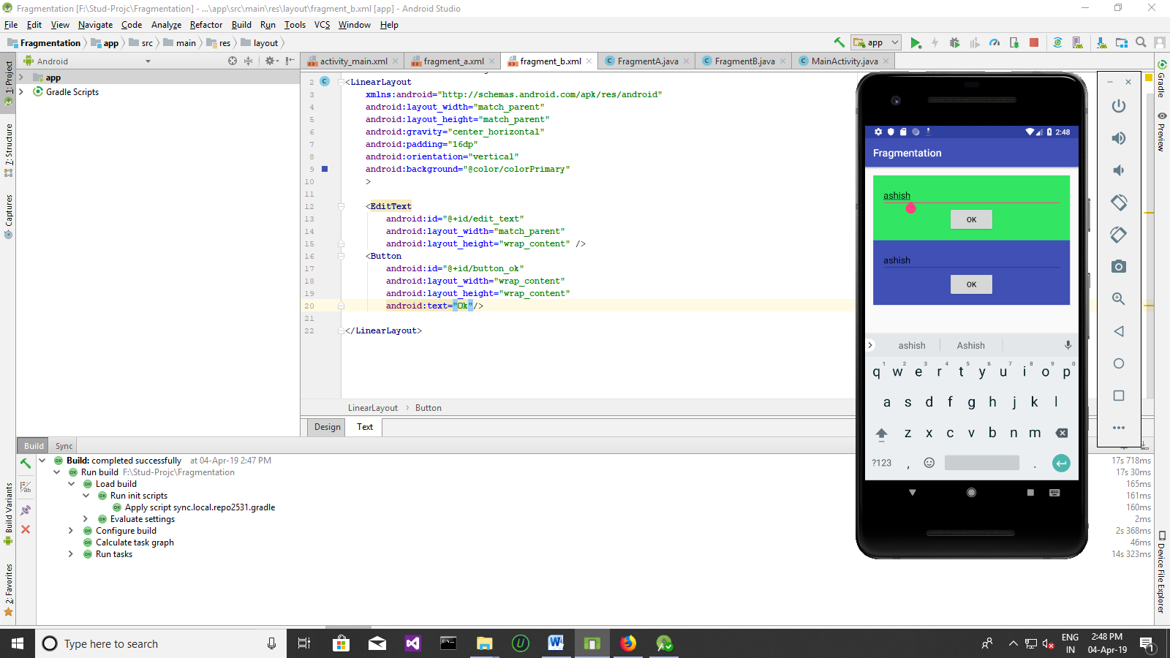

4)UI components

**Practical 6 UI Elements**

1. Creating Menu’s

Activity_main.xml

*<?***xml version="1.0" encoding="utf-8"***?>*<**LinearLayout xmlns:android="http://schemas.android.com/apk/res/android"  
 xmlns:app="http://schemas.android.com/apk/res-auto"  
 xmlns:tools="http://schemas.android.com/tools"  
 android:layout_width="match_parent"  
 android:layout_height="match_parent"  
 tools:context=".MainActivity"  
 android:orientation="vertical"** >  
 <**include  
 layout="@layout/toolbar_layout"**/>  
</**LinearLayout**>

Toolbar_layout.xml

*<?***xml version="1.0" encoding="utf-8"***?>*<**android.support.v7.widget.Toolbar xmlns:android="http://schemas.android.com/apk/res/android"  
 android:layout_width="match_parent"  
 android:layout_height="?attr/actionBarSize"  
 xmlns:app="http://schemas.android.com/apk/res-auto"  
 android:background="?attr/colorPrimary"  
 android:theme="@style/ThemeOverlay.AppCompat.Dark.ActionBar"  
 app:popupTheme="@style/ThemeOverlay.AppCompat.Light"  
 android:id="@+id/toolBar"** >  
</**android.support.v7.widget.Toolbar**>

MainActivity.java

**package** com.example.amd.uielements;  
  
**import** android.support.v7.app.AppCompatActivity;  
**import** android.os.Bundle;  
**import** android.support.v7.widget.Toolbar;  
**import** android.view.Menu;  
**import** android.view.MenuInflater;  
**import** android.view.MenuItem;  
**import** android.widget.Toast;  
  
  
**public class** MainActivity **extends** AppCompatActivity {  
 **private** android.support.v7.widget.Toolbar **tbar**;  
  
 @Override  
 **protected void** onCreate(Bundle savedInstanceState) {  
 **super**.onCreate(savedInstanceState);  
 setContentView(R.layout.***activity_main***);  
 **tbar**=findViewById(R.id.***toolBar***);  
 setSupportActionBar(**tbar**);  
 }  
  
 @Override  
 **public boolean** onCreateOptionsMenu(Menu menu) {  
 MenuInflater mi=getMenuInflater();  
 mi.inflate(R.menu.***app_bar_menu***,menu);  
 **return true**;  
 }  
  
 @Override  
 **public boolean** onOptionsItemSelected(MenuItem item) {  
 **switch** (item.getItemId()){  
 **case** R.id.***action_search***:  
 Toast.*makeText*(**this**,**"Search menu is clicked"**,Toast.***LENGTH_LONG***).show();  
 **return true**;  
 **case** R.id.***action_about***:  
 Toast.*makeText*(**this**,**"About menu is clicked"**,Toast.***LENGTH_LONG***).show();  
 **return true**;  
 **case** R.id.***action_info***:  
 Toast.*makeText*(**this**,**"info menu is clicked"**,Toast.***LENGTH_LONG***).show();  
 **return true**;  
 **case** R.id.***action_image***:  
 Toast.*makeText*(**this**,**"image menu is clicked"**,Toast.***LENGTH_LONG***).show();  
 **return true**;  
  
 **default**:  
 **return super**.onOptionsItemSelected(item);  
 }  
 }  
}

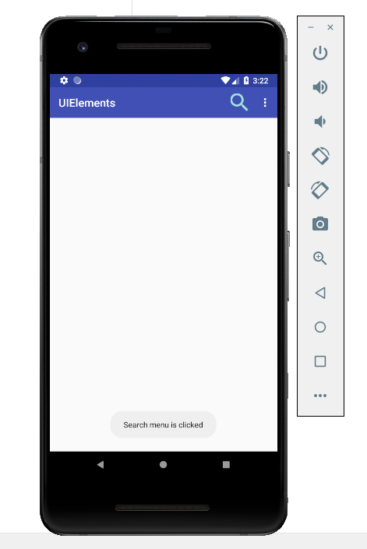

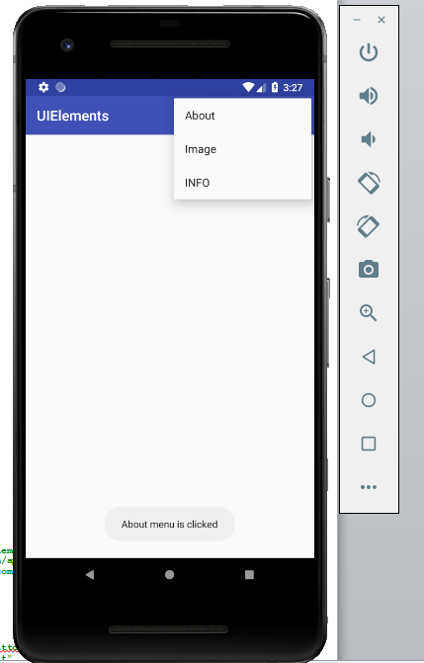

1. Creating Dialog

Activity_main.xml

*<?***xml version="1.0" encoding="utf-8"***?>*<**RelativeLayout xmlns:android="http://schemas.android.com/apk/res/android"  
 xmlns:app="http://schemas.android.com/apk/res-auto"  
 xmlns:tools="http://schemas.android.com/tools"  
 android:layout_width="match_parent"  
 android:layout_height="match_parent"  
 tools:context=".MainActivity"**>  
  
 <**Button  
 android:id="@+id/button48"  
 style="@style/Widget.AppCompat.Button.Colored"  
 android:layout_width="wrap_content"  
 android:layout_height="wrap_content"  
 android:layout_alignParentTop="true"  
 android:layout_centerHorizontal="true"  
 android:layout_marginTop="183dp"  
 android:onClick="onAlert"  
 android:text="Click m e to View Alert Dialog"** />  
</**RelativeLayout**>

MainActivity.xml

**package** com.example.amd.dialog;  
  
**import** android.app.Activity;  
**import** android.content.DialogInterface;  
**import** android.content.Intent;  
**import** android.os.Bundle;  
**import** android.support.v7.app.AlertDialog;  
**import** android.view.View;  
  
**public class** MainActivity **extends** Activity {  
 @Override  
 **protected void** onCreate(Bundle savedInstanceState) {  
 **super**.onCreate(savedInstanceState);  
 setContentView(R.layout.***activity_main***);  
 }  
  
 **public void** onAlert(View view) {  
 *//Create Builder* AlertDialog.Builder build = **new** AlertDialog.Builder(**this**);  
 build.setCancelable(**false**);  
 build.setTitle(**"Alert Dialog"**);  
 build.setMessage(**"Hey! Welcome It's an Alert Dialog"**);  
  
 *////////Set Buttons For Dialogs* build.setPositiveButton(**"Ok!!"**, **new** DialogInterface.OnClickListener() {  
 @Override  
 **public void** onClick(DialogInterface dialog, **int** which) {  
 *//You Can Set Your Own Actions Here* }  
 });  
 *///Create and Show the Dialog* build.create().show();  
 }  
}

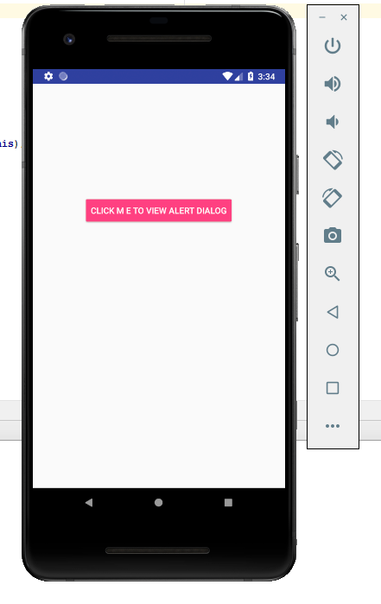 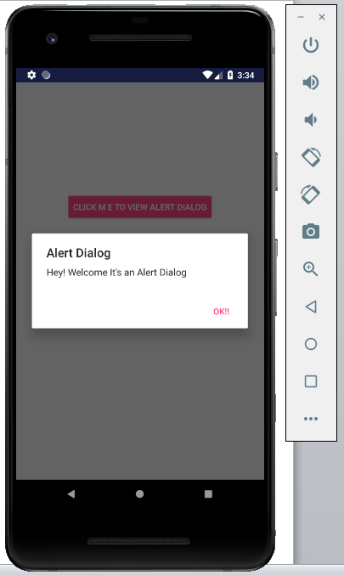

**Practical 7 The Android Intent**

Activity_main.xml

*<?***xml version="1.0" encoding="utf-8"***?>*<**RelativeLayout xmlns:android="http://schemas.android.com/apk/res/android"  
 xmlns:app="http://schemas.android.com/apk/res-auto"  
 xmlns:tools="http://schemas.android.com/tools"  
 android:layout_width="match_parent"  
 android:layout_height="match_parent"  
 android:background="@android:color/background_light"  
 tools:context=".MainActivity"**>  
  
 <**Button  
 android:id="@+id/button34"  
 style="@style/Widget.AppCompat.Button.Colored"  
 android:layout_width="match_parent"  
 android:layout_height="wrap_content"  
 android:layout_alignParentTop="true"  
 android:layout_centerHorizontal="true"  
 android:layout_marginTop="208dp"  
 android:onClick="onSend"  
 android:text="Send to Others"** />  
  
 <**TextView  
 android:id="@+id/textView94"  
 android:layout_width="wrap_content"  
 android:layout_height="wrap_content"  
 android:layout_alignParentTop="true"  
 android:layout_centerHorizontal="true"  
 android:layout_marginTop="30dp"  
 android:text="Activity 1"  
 android:textAppearance="@style/TextAppearance.AppCompat.Display1"  
 android:textColor="@color/colorPrimary"** />  
  
 <**EditText  
 android:id="@+id/SendingText"  
 android:layout_width="match_parent"  
 android:layout_height="wrap_content"  
 android:layout_alignParentStart="true"  
 android:layout_below="@+id/textView94"  
 android:layout_marginTop="62dp"  
 android:ems="10"  
 android:hint="Sending Message"  
 android:inputType="textPersonName"  
 android:layout_alignParentLeft="true"** />  
</**RelativeLayout**>

Activity_edit_text.xml

*<?***xml version="1.0" encoding="utf-8"***?>*<**RelativeLayout xmlns:android="http://schemas.android.com/apk/res/android"  
 xmlns:app="http://schemas.android.com/apk/res-auto"  
 xmlns:tools="http://schemas.android.com/tools"  
 android:id="@+id/ChangableText"  
 android:layout_width="match_parent"  
 android:layout_height="match_parent"  
 tools:context=".editTextActivity"**>  
  
 <**TextView  
 android:id="@+id/TextSending"  
 android:layout_width="wrap_content"  
 android:layout_height="wrap_content"  
 android:layout_alignParentTop="true"  
 android:layout_centerHorizontal="true"  
 android:layout_marginTop="79dp"  
 android:text="TextView"  
 android:textAppearance="@style/TextAppearance.AppCompat.Display1"  
 tools:layout_editor_absoluteX="113dp"  
 tools:layout_editor_absoluteY="95dp"** />  
</**RelativeLayout**>

MainActivity.java

**package** com.example.amd.intents;  
  
**import** android.content.Intent;  
**import** android.os.Bundle;  
**import** android.support.v7.app.AppCompatActivity;  
**import** android.view.View;  
**import** android.widget.EditText;  
  
**import** com.example.amd.intents.R;  
  
**public class** MainActivity **extends** AppCompatActivity {  
 String **Values**;  
  
 @Override  
 **protected void** onCreate(Bundle savedInstanceState) {  
 **super**.onCreate(savedInstanceState);  
 setContentView(R.layout.***activity_main***);  
  
  
 }  
  
 **public void** onSend(View view) {  
 Intent oppp = **new** Intent(**this**, editTextActivity.**class**);  
 **final** EditText myEditText = (EditText) findViewById(R.id.***SendingText***);  
 **Values** = myEditText.getText().toString();  
 oppp.putExtra(**"valuesData"**, **Values**);  
 startActivity(oppp);  
 }  
}

editTextActivity.java

**package** com.example.amd.intents;  
  
**import** android.os.Bundle;  
**import** android.support.v7.app.AppCompatActivity;  
**import** android.widget.TextView;  
  
**public class** editTextActivity **extends** AppCompatActivity {  
  
 @Override  
 **protected void** onCreate(Bundle savedInstanceState) {  
 **super**.onCreate(savedInstanceState);  
 setContentView(R.layout.***activity_edit_text***);  
  
 Bundle datas=getIntent().getExtras();  
 **if**(datas==**null**){  
 **return**;  
 }  
 String RecieveText=datas.getString(**"valuesData"**);  
 **final** TextView myt=(TextView)findViewById(R.id.***TextSending***);  
 myt.setText(RecieveText);  
 }  
}

AndroidManifeast.xml

*<?***xml version="1.0" encoding="utf-8"***?>*<**manifest xmlns:android="http://schemas.android.com/apk/res/android"  
 package="com.example.amd.intents"**>  
  
 <**application  
 android:allowBackup="true"  
 android:icon="@mipmap/ic_launcher"  
 android:label="@string/app_name"  
 android:roundIcon="@mipmap/ic_launcher_round"  
 android:supportsRtl="true"  
 android:theme="@style/AppTheme"**>  
 <**activity android:name=".MainActivity"**>  
 <**intent-filter**>  
 <**action android:name="android.intent.action.MAIN"** />  
  
 <**category android:name="android.intent.category.LAUNCHER"** />  
 </**intent-filter**>  
 </**activity**>  
 <**activity android:name=".editTextActivity"**>  
 </**activity**>  
 </**application**>  
  
</**manifest**>

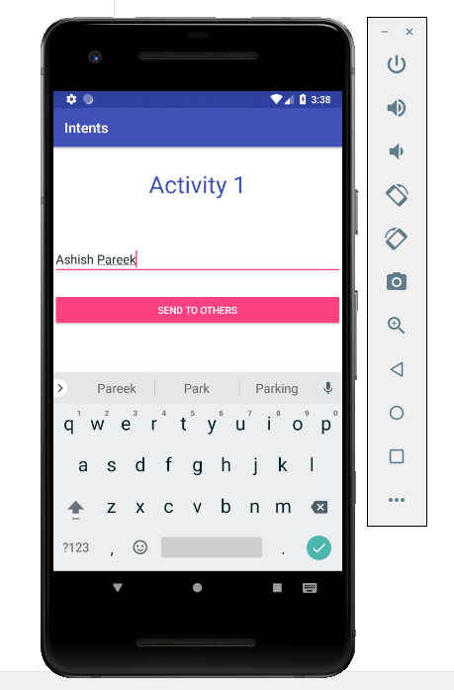 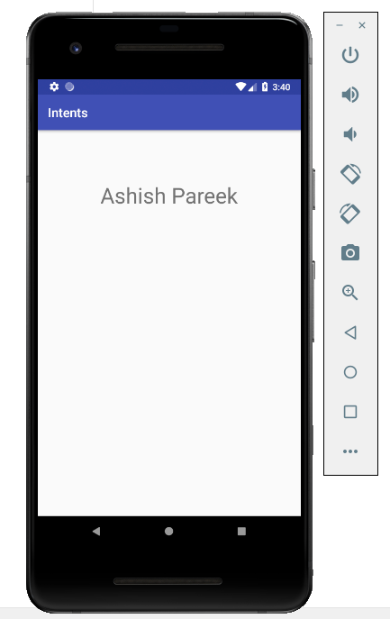

Practical 8

1. Android Services
2. Program on Notifications

**Practical 9**

Database programming with SQL lite and Internal storage

1. Internal storage
2. SQL lite
3. Internal storage

**activity_main.xml**

<**RelativeLayout xmlns:android="http://schemas.android.com/apk/res/android"  
 xmlns:tools="http://schemas.android.com/tools"  
 android:layout_width="match_parent"  
 android:layout_height="match_parent"  
 tools:context=".MainActivity"** >  
  
 <**EditText  
 android:id="@+id/editText1"  
 android:layout_width="wrap_content"  
 android:layout_height="wrap_content"  
 android:layout_alignParentRight="true"  
 android:layout_alignParentTop="true"  
 android:layout_marginRight="20dp"  
 android:layout_marginTop="24dp"  
 android:ems="10"** >  
  
 <**requestFocus** />  
 </**EditText**>  
  
 <**EditText  
 android:id="@+id/editText2"  
 android:layout_width="wrap_content"  
 android:layout_height="wrap_content"  
 android:layout_alignRight="@+id/editText1"  
 android:layout_below="@+id/editText1"  
 android:layout_marginTop="24dp"  
 android:ems="10"** />  
  
 <**TextView  
 android:id="@+id/textView1"  
 android:layout_width="wrap_content"  
 android:layout_height="wrap_content"  
 android:layout_alignBaseline="@+id/editText1"  
 android:layout_alignBottom="@+id/editText1"  
 android:layout_alignParentLeft="true"  
 android:text="File Name:"** />  
  
 <**TextView  
 android:id="@+id/textView2"  
 android:layout_width="wrap_content"  
 android:layout_height="wrap_content"  
 android:layout_alignBaseline="@+id/editText2"  
 android:layout_alignBottom="@+id/editText2"  
 android:layout_alignParentLeft="true"  
 android:text="Data:"** />  
  
 <**Button  
 android:id="@+id/button1"  
 android:layout_width="wrap_content"  
 android:layout_height="wrap_content"  
 android:layout_alignLeft="@+id/editText2"  
 android:layout_below="@+id/editText2"  
 android:layout_marginLeft="70dp"  
 android:layout_marginTop="16dp"  
 android:text="save"** />  
  
 <**Button  
 android:id="@+id/button2"  
 android:layout_width="wrap_content"  
 android:layout_height="wrap_content"  
 android:layout_alignBaseline="@+id/button1"  
 android:layout_alignBottom="@+id/button1"  
 android:layout_toRightOf="@+id/button1"  
 android:text="read"** />  
  
</**RelativeLayout**>

**MainActivity.java**

**package** com.example.amd.internal;  
  
**import** android.content.Context;  
**import** android.support.v7.app.AppCompatActivity;  
**import** android.os.Bundle;  
**import** android.view.View;  
**import** android.widget.Button;  
**import** android.widget.EditText;  
**import** android.widget.Toast;  
  
**import** java.io.BufferedReader;  
**import** java.io.FileNotFoundException;  
**import** java.io.FileOutputStream;  
**import** java.io.IOException;  
**import** java.io.InputStreamReader;  
  
**public class** MainActivity **extends** AppCompatActivity {  
 EditText **editTextFileName**,**editTextData**;  
 Button **saveButton**,**readButton**;  
 @Override  
 **protected void** onCreate(Bundle savedInstanceState) {  
 **super**.onCreate(savedInstanceState);  
 setContentView(R.layout.***activity_main***);  
  
 **editTextFileName**=findViewById(R.id.***editText1***);  
 **editTextData**=findViewById(R.id.***editText2***);  
 **saveButton**=findViewById(R.id.***button1***);  
 **readButton**=findViewById(R.id.***button2***);  
  
 *//Performing Action on Read Button* **saveButton**.setOnClickListener(**new** View.OnClickListener(){  
  
 @Override  
 **public void** onClick(View arg0) {  
 String filename=**editTextFileName**.getText().toString();  
 String data=**editTextData**.getText().toString();  
  
 FileOutputStream fos;  
 **try** {  
 fos = openFileOutput(filename, Context.***MODE_PRIVATE***);  
 *//default mode is PRIVATE, can be APPEND etc.* fos.write(data.getBytes());  
 fos.close();  
  
 Toast.*makeText*(getApplicationContext(),filename + **" saved"**,  
 Toast.***LENGTH_LONG***).show();  
  
  
 } **catch** (FileNotFoundException e) {e.printStackTrace();}  
 **catch** (IOException e) {e.printStackTrace();}  
  
 }  
  
 });  
  
 *//Performing Action on Read Button* **readButton**.setOnClickListener(**new** View.OnClickListener(){  
  
 @Override  
 **public void** onClick(View arg0) {  
 String filename=**editTextFileName**.getText().toString();  
 StringBuffer stringBuffer = **new** StringBuffer();  
 **try** {  
 *//Attaching BufferedReader to the FileInputStream by the help of InputStreamReader* BufferedReader inputReader = **new** BufferedReader(**new** InputStreamReader(  
 openFileInput(filename)));  
 String inputString;  
 *//Reading data line by line and storing it into the stringbuffer* **while** ((inputString = inputReader.readLine()) != **null**) {  
 stringBuffer.append(inputString + **"\n"**);  
 }  
  
 } **catch** (IOException e) {  
 e.printStackTrace();  
 }  
 *//Displaying data on the toast* Toast.*makeText*(getApplicationContext(),stringBuffer.toString(),Toast.***LENGTH_LONG***).show();  
  
 }  
  
 });  
 }  
}

**output :-**

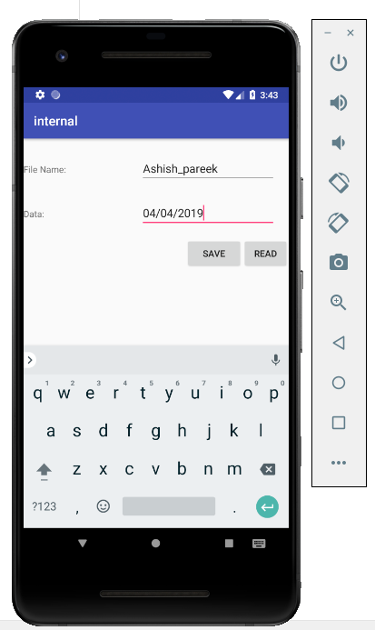 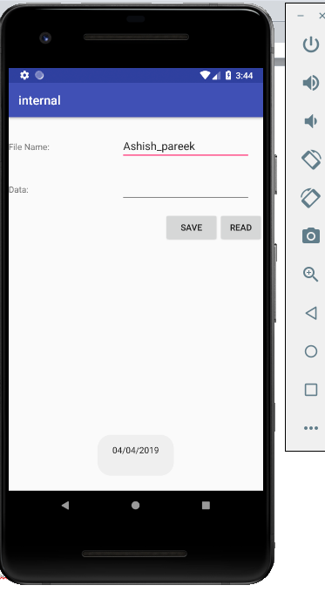

**SAVE READ**

1. **SQL lite**

**activity_main.xml**

*<?***xml version="1.0" encoding="utf-8"***?>*<**RelativeLayout xmlns:android="http://schemas.android.com/apk/res/android"  
 xmlns:app="http://schemas.android.com/apk/res-auto"  
 xmlns:tools="http://schemas.android.com/tools"  
 android:layout_width="match_parent"  
 android:layout_height="match_parent"  
 tools:context=".MainActivity"**>  
  
  
 <**EditText  
 android:id="@+id/input_label"  
 android:layout_width="wrap_content"  
 android:layout_height="wrap_content"  
 android:layout_alignParentTop="true"  
 android:layout_centerHorizontal="true"  
 android:layout_marginTop="46dp"  
 android:hint="Add item"  
 android:ems="10"** />  
  
 <**Button  
 android:id="@+id/btn_add"  
 android:layout_width="wrap_content"  
 android:layout_height="wrap_content"  
 android:layout_below="@+id/input_label"  
 android:layout_centerHorizontal="true"  
 android:layout_marginTop="67dp"  
 android:text="Add item"** />  
  
 <**Spinner  
 android:id="@+id/spinner"  
 android:layout_width="match_parent"  
 android:layout_height="wrap_content"  
 android:layout_alignParentLeft="true"  
 android:layout_alignParentStart="true"  
 android:layout_below="@+id/btn_add"  
 android:layout_marginTop="70dp"** />  
</**RelativeLayout**>

**MainActivity.java**

**package** com.example.amd.sql_lite;  
**import** android.content.Context;  
**import** android.support.v7.app.AppCompatActivity;  
**import** android.os.Bundle;  
**import** android.view.View;  
**import** android.view.inputmethod.InputMethodManager;  
**import** android.widget.AdapterView;  
**import** android.widget.ArrayAdapter;  
**import** android.widget.Button;  
**import** android.widget.EditText;  
**import** android.widget.Spinner;  
**import** android.widget.Toast;  
**import** java.util.List;  
  
**public class** MainActivity **extends** AppCompatActivity **implements** AdapterView.OnItemSelectedListener {  
 Spinner **spinner**;  
 Button **btnAdd**;  
 EditText **inputLabel**;  
 @Override  
 **protected void** onCreate(Bundle savedInstanceState) {  
 **super**.onCreate(savedInstanceState);  
 setContentView(R.layout.***activity_main***);  
 **spinner** = findViewById(R.id.***spinner***);  
 **btnAdd** = findViewById(R.id.***btn_add***);  
 **inputLabel** = findViewById(R.id.***input_label***);  
  
 **spinner**.setOnItemSelectedListener(**this**);  
  
 *// Loading spinner data from database* loadSpinnerData();  
  
 **btnAdd**.setOnClickListener(**new** View.OnClickListener() {  
  
 @Override  
 **public void** onClick(View arg0) {  
 String label = **inputLabel**.getText().toString();  
  
 **if** (label.trim().length() > 0) {  
 DatabaseHandler db = **new** DatabaseHandler(getApplicationContext());  
 db.insertLabel(label);  
  
 *// making input filed text to blank* **inputLabel**.setText(**""**);  
  
 *// Hiding the keyboard* InputMethodManager imm = (InputMethodManager)  
 getSystemService(Context.***INPUT_METHOD_SERVICE***);  
 imm.hideSoftInputFromWindow(**inputLabel**.getWindowToken(), 0);  
 *// loading spinner with newly added data* loadSpinnerData();  
 } **else** {  
 Toast.*makeText*(getApplicationContext(), **"Please enter label name"**,  
 Toast.***LENGTH_SHORT***).show();  
 }  
  
 }  
 });  
 }  
  
 */**  
 * Function to load the spinner data from SQLite database  
 * */* **private void** loadSpinnerData() {  
 DatabaseHandler db = **new** DatabaseHandler(getApplicationContext());  
 List<String> labels = db.getAllLabels();  
  
 *// Creating adapter for spinner* ArrayAdapter<String> dataAdapter = **new** ArrayAdapter<String>(**this**,android.R.layout.***simple_spinner_item***, labels);  
  
 *// Drop down layout style - list view with radio button* dataAdapter.setDropDownViewResource(android.R.layout.***simple_spinner_dropdown_item***);  
  
 *// attaching data adapter to spinner* **spinner**.setAdapter(dataAdapter);  
 }  
  
 @Override  
 **public void** onItemSelected(AdapterView<?> parent, View view, **int** position,  
 **long** id) {  
 *// On selecting a spinner item* String label = parent.getItemAtPosition(position).toString();  
  
 *// Showing selected spinner item* Toast.*makeText*(parent.getContext(), **"You selected: "** + label,  
 Toast.***LENGTH_LONG***).show();  
  
 }  
  
 @Override  
 **public void** onNothingSelected(AdapterView<?> arg0) {  
 *//* ***TODO Auto-generated method stub*** }  
}

**DataBaseHandler.java**

**package** com.example.amd.sql_lite;  
  
**import** android.content.ContentValues;  
**import** android.content.Context;  
**import** android.database.Cursor;  
**import** android.database.sqlite.SQLiteDatabase;  
**import** android.database.sqlite.SQLiteOpenHelper;  
**import** java.util.ArrayList;  
**import** java.util.List;  
**public class** DatabaseHandler **extends** SQLiteOpenHelper {  
 **private static final int *DATABASE_VERSION*** = 1;  
 **private static final** String ***DATABASE_NAME*** = **"spinnerExample"**;  
 **private static final** String ***TABLE_NAME*** = **"labels"**;  
 **private static final** String ***COLUMN_ID*** = **"id"**;  
 **private static final** String ***COLUMN_NAME*** = **"name"**;  
  
 **public** DatabaseHandler(Context context) {  
 **super**(context, ***DATABASE_NAME***, **null**, ***DATABASE_VERSION***);  
 }  
  
 *// Creating Tables* @Override  
 **public void** onCreate(SQLiteDatabase db) {  
 *// Category table create query* String CREATE_ITEM_TABLE = **"CREATE TABLE "** + ***TABLE_NAME*** + **"("** + ***COLUMN_ID*** + **" INTEGER PRIMARY KEY,"** + ***COLUMN_NAME*** + **" TEXT)"**;  
 db.execSQL(CREATE_ITEM_TABLE);  
 }  
  
 *// Upgrading database* @Override  
 **public void** onUpgrade(SQLiteDatabase db, **int** oldVersion, **int** newVersion) {  
 *// Drop older table if existed* db.execSQL(**"DROP TABLE IF EXISTS "** + ***TABLE_NAME***);  
  
 *// Create tables again* onCreate(db);  
 }  
  
 */**  
 * Inserting new lable into lables table* **public void** insertLabel(String label){  
 SQLiteDatabase db = **this**.getWritableDatabase();  
  
 ContentValues values = **new** ContentValues();  
 values.put(***COLUMN_NAME***, label);*//column name, column value  
  
 // Inserting Row* db.insert(***TABLE_NAME***, **null**, values);*//tableName, nullColumnHack, CotentValues* db.close(); *// Closing database connection* }  
  
 */**  
 * Getting all labels  
 * returns list of labels  
 * */* **public** List<String> getAllLabels(){  
 List<String> list = **new** ArrayList<String>();  
  
 *// Select All Query* String selectQuery = **"SELECT * FROM "** + ***TABLE_NAME***;  
  
 SQLiteDatabase db = **this**.getReadableDatabase();  
 Cursor cursor = db.rawQuery(selectQuery, **null**);*//selectQuery,selectedArguments  
  
 // looping through all rows and adding to list* **if** (cursor.moveToFirst()) {  
 **do** {  
 list.add(cursor.getString(1));*//adding 2nd column data* } **while** (cursor.moveToNext());  
 }  
 *// closing connection* cursor.close();  
 db.close();  
 *// returning lables* **return** list;  
 }  
}

OutPut:

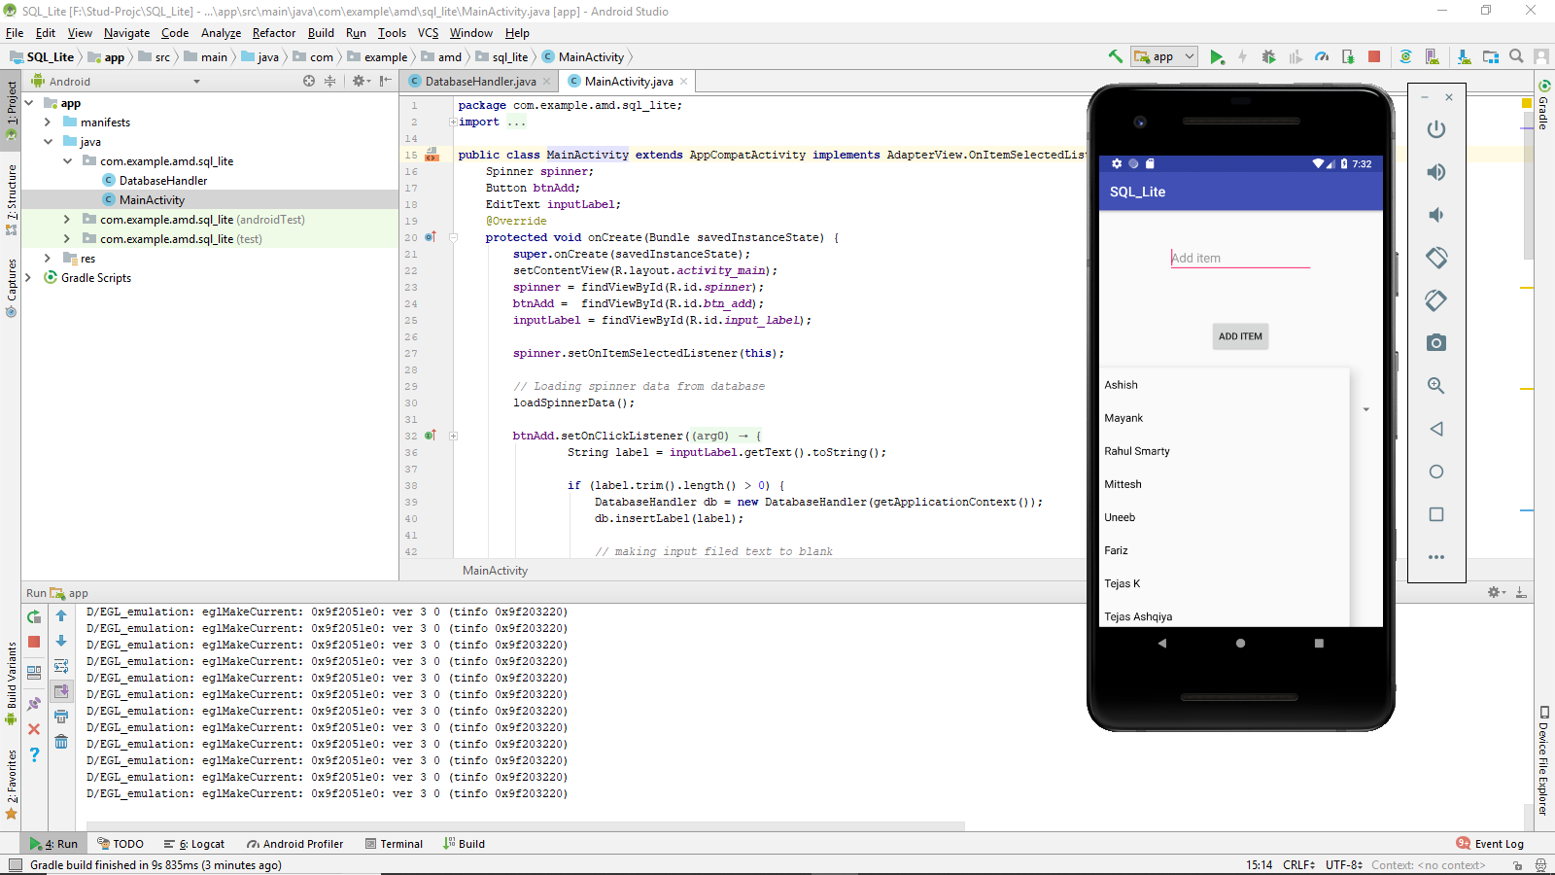

Example 2

activity_main.xml

*<?***xml version="1.0" encoding="utf-8"***?>*<**RelativeLayout xmlns:android="http://schemas.android.com/apk/res/android"  
 xmlns:app="http://schemas.android.com/apk/res-auto"  
 xmlns:tools="http://schemas.android.com/tools"  
 android:layout_width="match_parent"  
 android:layout_height="match_parent"  
 android:gravity="center"  
 android:paddingLeft="10dp"  
 android:paddingRight="10dp"  
 tools:context=".MainActivity"** >  
 <**EditText  
 android:layout_width="match_parent"  
 android:layout_height="wrap_content"  
 android:hint="Enter id to update or delete"  
 android:id="@+id/id"  
 android:onClick="buttonAction"**/>  
  
 <**EditText  
 android:layout_width="match_parent"  
 android:layout_height="wrap_content"  
 android:hint="Enter name to insert or update"  
 android:id="@+id/name"  
 android:layout_below="@+id/id"  
 android:layout_marginTop="10dp"**/>  
  
 <**LinearLayout  
 android:layout_width="match_parent"  
 android:layout_height="wrap_content"  
 android:layout_below="@+id/name"  
 android:id="@+id/layout1"  
 android:orientation="vertical"**>  
 <**Button  
 android:layout_width="match_parent"  
 android:layout_height="wrap_content"  
 android:id="@+id/insert"  
 android:text="Insert"  
 android:onClick="buttonAction"**/>  
  
 <**Button  
 android:layout_width="match_parent"  
 android:layout_height="wrap_content"  
 android:id="@+id/view"  
 android:text="View"  
 android:onClick="buttonAction"  
 android:layout_below="@+id/name"**/>  
  
 <**Button  
 android:layout_width="match_parent"  
 android:layout_height="wrap_content"  
 android:text="Update"  
 android:onClick="buttonAction"  
 android:id="@+id/update"  
 android:layout_below="@+id/name"**/>  
  
 <**Button  
 android:layout_width="match_parent"  
 android:layout_height="wrap_content"  
 android:text="Delete"  
 android:onClick="buttonAction"  
 android:id="@+id/delete"** />  
  
 </**LinearLayout**>  
  
 <**TextView  
 android:id="@+id/text"  
 android:layout_width="401dp"  
 android:layout_height="217dp"  
 android:layout_below="@+id/layout1"  
 android:layout_marginTop="87dp"** />  
</**RelativeLayout**>

MainActivity.java

**package** com.example.amd.uicomponent;  
  
  
**import** android.provider.ContactsContract;  
**import** android.support.v7.app.AppCompatActivity;  
**import** android.os.Bundle;  
**import** android.view.View;  
**import** android.widget.AdapterView;  
**import** android.widget.Button;  
**import** android.widget.EditText;  
**import** android.widget.TextView;  
**import** android.widget.Toast;  
  
**public class** MainActivity **extends** AppCompatActivity {  
  
 EditText **id**, **name**;  
 Button **insert**, **view**, **update**, **delete**;  
 TextView **text**;  
 DBHandler **db**;  
  
  
 @Override  
 **protected void** onCreate(Bundle savedInstanceState) {  
 **super**.onCreate(savedInstanceState);  
 setContentView(R.layout.***activity_main***);  
 **id** = (EditText) findViewById(R.id.***id***);  
 **name** = (EditText) findViewById((R.id.***name***));  
 **insert** = (Button) findViewById(R.id.***insert***);  
 **view** = (Button) findViewById(R.id.***view***);  
 **update** = (Button) findViewById(R.id.***update***);  
 **delete** = (Button) findViewById(R.id.***delete***);  
 **text** = (TextView) findViewById(R.id.***text***);  
  
 **db** = **new** DBHandler(getApplicationContext());  
  
  
 }  
  
 **public void** buttonAction(View view) {  
 **switch** (view.getId()) {  
 **case** R.id.***insert***:  
 **db**.insertRecord(**name**.getText().toString());  
 Toast.*makeText*(getApplicationContext(), **"record inserted"**, Toast.***LENGTH_LONG***).show();  
 **break**;  
 **case** R.id.***view***:  
 **text**.setText(**db**.getRecords());  
 **break**;  
 **case** R.id.***update***:  
 **db**.updateRecord(**id**.getText().toString(), **name**.getText().toString());  
 Toast.*makeText*(getApplicationContext(), **"record updated"**, Toast.***LENGTH_LONG***).show();  
 **break**;  
 **case** R.id.***delete***:  
 **db**.deleteRecord(**id**.getText().toString());  
 Toast.*makeText*(getApplicationContext(), **"record deleted"**, Toast.***LENGTH_LONG***).show();  
 **break**;  
  
 }  
 }  
}

DBHandler.java

**package** com.example.amd.uicomponent;  
**import** android.content.ContentValues;  
**import** android.content.Context;  
**import** android.database.Cursor;  
**import** android.database.sqlite.SQLiteDatabase;  
**import** android.database.sqlite.SQLiteOpenHelper;  
  
**import** java.util.ArrayList;  
  
**public class** DBHandler **extends** SQLiteOpenHelper{  
 **private static final** String ***DB_NAME***=**"demodb"**;  
 **private static final int *DB_VERSION***=1;  
 **private static final** String ***TABLE_NAME***=**"record"**;  
 **private static final** String ***ID_COL***=**"id"**;  
 **private static final** String ***NAME_COL***=**"name"**;  
  
 **public** DBHandler(Context context) {  
 **super**(context, ***DB_NAME***, **null**, ***DB_VERSION***);  
 }  
  
 @Override  
 **public void** onCreate(SQLiteDatabase db) {  
 String query=**"CREATE TABLE "**+***TABLE_NAME***+**" ("**+***ID_COL***+**" INTEGER PRIMARY KEY AUTOINCREMENT,"**+***NAME_COL***+**" TEXT)"**;  
 db.execSQL(query);  
 }  
  
 @Override  
 **public void** onUpgrade(SQLiteDatabase db, **int** oldVersion, **int** newVersion) {  
 *// Drop older table if existed* db.execSQL(**"DROP TABLE IF EXISTS "** + ***TABLE_NAME***);  
  
 *// Create table again* onCreate(db);  
 }  
  
 **public void** insertRecord(String name){  
 SQLiteDatabase db=**this**.getWritableDatabase();  
 ContentValues values=**new** ContentValues();  
  
 values.put(***NAME_COL***,name);  
 db.insert(***TABLE_NAME***,**null**,values);  
 db.close();  
 }  
  
 **public** String getRecords(){  
 String query=**"SELECT * FROM "**+***TABLE_NAME***;  
 String result=**""**;  
 SQLiteDatabase db=**this**.getReadableDatabase();  
 Cursor cursor=db.rawQuery(query,**null**);  
  
 cursor.moveToFirst();  
 **while**(cursor.isAfterLast()==**false**){  
 result+=cursor.getString(0)+**" "**+cursor.getString(1)+**"\n"**;  
 cursor.moveToNext();  
 }  
  
 db.close();  
 **return** result;  
 }  
  
 **public void** updateRecord(String id,String name){  
 SQLiteDatabase db=**this**.getWritableDatabase();  
 ContentValues values=**new** ContentValues();  
 values.put(***NAME_COL***,name);  
  
 db.update(***TABLE_NAME***,values,**"id=?"**,**new** String[]{id});  
 db.close();  
 }  
  
 **public void** deleteRecord(String id){  
 SQLiteDatabase db=**this**.getWritableDatabase();  
 db.delete(***TABLE_NAME***,**"id=?"**,**new** String[]{id});  
  
 db.close();  
 }  
}

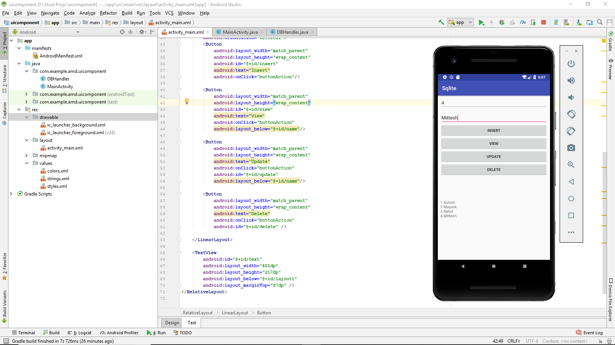

**Practical No:10**

* **Aim:** Programming Security and permissions
* **Coding:**
* Extra Packages requied in ManagePermission.kt (Class File)

import android.app.Activity

import android.content.pm.PackageManager

import android.support.v4.app.ActivityCompat

import android.support.v4.content.ContextCompat

import android.support.v7.app.AlertDialog

* **Extra Packages requied in MainActivity.kt**

import android.Manifest

import android.content.Context

import android.os.Build

import android.widget.Toast

import kotlinx.android.synthetic.main.activity_main.*

* **For Multple Permission Access,need to add following line in class MainActivity**

**private val PermissionsRequestCode = 123**

1. Create a new project in android studio

2. An app must publicize the permissions it requires by including <uses-permission> tags in the app manifest.

<uses-permission android:name="android.permission.INTERNET" />

<uses-permission android:name="android.permission.CAMERA"/>

<uses-permission android:name="android.permission.READ_CONTACTS"/>

<uses-permission android:name="android.permission.READ_EXTERNAL_STORAGE"/>

<uses-permission android:name="android.permission.SEND_SMS"/>

<uses-permission android:name="android.permission.READ_CALENDAR"/>

**3. MainActivity.kt**

package com.example.admin.permissionappdemo

import android.Manifest

import android.content.Context

import android.os.Build

import android.support.v7.app.AppCompatActivity

import android.os.Bundle

import android.widget.Toast

import kotlinx.android.synthetic.main.activity_main.*

class MainActivity : AppCompatActivity() {

private val PermissionsRequestCode = 123

private lateinit var managePermissions: ManagePermissions

override fun onCreate(savedInstanceState: Bundle?) {

super.onCreate(savedInstanceState)

setContentView(R.layout.*activity_main*)

*// Initialize a list of required permissions to request runtime*

val list = *listOf*<String>(

Manifest.permission.*CAMERA*,

Manifest.permission.*READ_CONTACTS*,

Manifest.permission.*READ_EXTERNAL_STORAGE*,

Manifest.permission.*SEND_SMS*,

Manifest.permission.*READ_CALENDAR* )

*// Initialize a new instance of ManagePermissions class*

managePermissions = ManagePermissions(this,list,PermissionsRequestCode)

*// Button to check permissions states*

button.setOnClickListener{

if (Build.VERSION.*SDK_INT* >= Build.VERSION_CODES.*M*) managePermissions.checkPermissions()

}

}

*// Receive the permissions request result*

override fun onRequestPermissionsResult(requestCode: Int, permissions: Array<String>, grantResults: IntArray) {

when (requestCode) {

PermissionsRequestCode ->{

val isPermissionsGranted = managePermissions .processPermissionsResult(requestCode,permissions,grantResults)

if(isPermissionsGranted){

*// Do the task now*

*toast*("Permissions granted.")

}else{

*toast*("Permissions denied.")

}

return

}

}

}

}

*// Extension function to show toast message*

fun Context.toast(message: String) {

Toast.makeText(this, message, Toast.*LENGTH_SHORT*).show()

}

**4. Create a New Kotlin Class**

**app->src->main->java->com.example.admin.permissionappdemo**

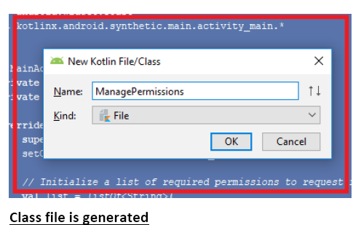

**5. Write the following code in the Class File**

import android.app.Activity

import android.content.pm.PackageManager

import android.support.v4.app.ActivityCompat

import android.support.v4.content.ContextCompat

import android.support.v7.app.AlertDialog

class ManagePermissions(val activity: Activity,val list: List<String>,val code:Int) {

*// Check permissions at runtime*

fun checkPermissions() {

if (isPermissionsGranted() != PackageManager.*PERMISSION_GRANTED*) {

showAlert()

} else {

activity.*toast*("Permissions already granted.")

}

}

*// Check permissions status*

private fun isPermissionsGranted(): Int {

*// PERMISSION_GRANTED : Constant Value: 0*

*// PERMISSION_DENIED : Constant Value: -1*

var counter = 0;

for (permission in list) {

counter += ContextCompat.checkSelfPermission(activity, permission)

}

return counter

}

*// Find the first denied permission*

private fun deniedPermission(): String {

for (permission in list) {

if (ContextCompat.checkSelfPermission(activity, permission) == PackageManager.*PERMISSION_DENIED*) return permission

}

return ""

}

*// Show alert dialog to request permissions*

private fun showAlert() {

val builder = AlertDialog.Builder(activity)

builder.setTitle("Need permission(s)")

builder.setMessage("Some permissions are required to do the task.") builder.setPositiveButton("OK", { dialog, which -> requestPermissions() }) builder.setNeutralButton("Cancel", null)

val dialog = builder.create()

dialog.show()

}

*// Request the permissions at run time*

private fun requestPermissions() {

val permission = deniedPermission()

if (ActivityCompat.shouldShowRequestPermissionRationale(activity, permission)) {

*// Show an explanation asynchronously*

activity.*toast*("Should show an explanation.")

} else {

ActivityCompat.requestPermissions(activity, list.*toTypedArray*(), code)

}

}

*// Process permissions result*

fun processPermissionsResult(requestCode: Int, permissions: Array<String>, grantResults: IntArray): Boolean {

var result = 0

if (grantResults.*isNotEmpty*()) {

for (item in grantResults) {

result += item

}

}

if (result == PackageManager.*PERMISSION_GRANTED*) return true

return false

}

}

**OUTPUT:**

